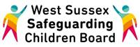

WELCOME to the WSSCB Broadcast Email
April 2017

Due to the previous Basic Awareness of Safer Sleeping Messages Workshop being such a huge success, another session has been arranged for the 24th April. This workshop is for those practitioners who have not previously received training in this area. For full details and to book your place click here

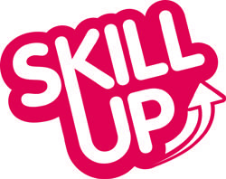
Are you a practitioner working directly with families? The Healthy Lifestyle Team from Public Health have provided information on resources to support the families you work with around smoking cessation. Click on the links below to find out more;
- Smoke Free Baby app
- Online information for smokers from Tommy's
- Start4Life website
Information for Professionals;
- Smoke Free Action
- NCSCT
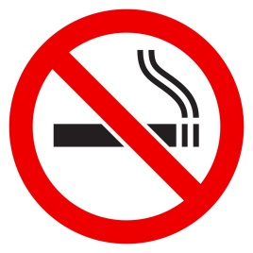
Nationally accredited training is also available on the National Centre for Smoking Cessation and Training website. Level 1 training supports how to raise the issue of smoking in a conversation, whilst to support someone through their smoking cessation journey requires the level 2 practitioner training which includes an assessment and certificate.
Click here for more details and to find out how you can support the families you work with.

There is currently a live “Have Your Say” survey for young people to complete with their support worker around self-harm. It is focused on the young person’s experiences of support and does not ask for details of the self-harm. It is important that young people are not asked to complete this survey independently.
Paper copies of the survey are also available for workers. If you would like a paper copy please contact the LSCB.
Responses will be used to improve the support that young people receive around self-harm. The closing date for completing this is 30th June 2017.
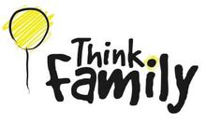
Click on this link to complete the survey with the young person you support; https://haveyoursay.westsussex.gov.uk/childrens- safeguarding-unit/04f7ff44/

To read the April edition of the Think Family/Early Help Newsletter click here

There are still a few places available on the Children and Young People Who Sexually Harm training on Monday 8th May This one day course is aimed at those working with young people and their carers to understand the issues arising from children and young people who sexually harm others and the implication for their service. The course will include interactive learning, case studies, research findings and make reference to the recent WSCC Serious Case Review, 'John'. The trainers delivering this course are Clinical Psychologists working in the Assessment and Treatment Service. Click here to request your place

If you have any information that you would like included in future email bulletins please contact me using the information below.

Kind Regards,

Lucy Short

Lucy Short, Learning & Development Officer
West Sussex Safeguarding Children Board | Location: 3rd Floor (East Wing), County Hall, Chichester, PO19 1RQ
Internal: 25508 | External: 033022 25508 | Mobile: 07850 537308
lucy.short@westsussex.gov.uk

