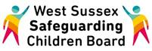

**WELCOME to the WSSCB Broadcast Email**

**October 2016**

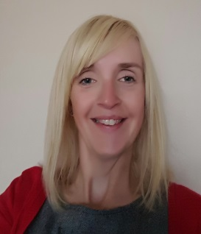My name is Lucy Short and I have recently joined the LSCB team as the Learning & Development Officer. I am responsible for overseeing the safeguarding training programme and working in partnership with a wide range of organisations to pass on safeguarding messages and updates from Serious Case Reviews, partner agencies and other sources. You can contact me through the LSCB website.

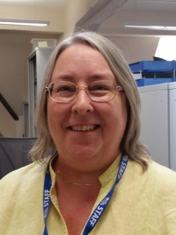Noni Entwistle has also joined the team as Performance Management Officer. She is responsible for the effective use of information from across the partnerships, to help the LSCB understand how effective it is in fulfilling its statutory obligations and to plan improvements. This is carried out in various ways, including introducing, monitoring and developing performance indicators for the Business Plan and Strategies, ensuring robust analysis of available information and supporting groups carrying out themed reviews. You can contact Noni through the LSCB website.

* A “Have Your Say” survey has been sent out to all agencies to gather feedback from practitioners about the Learning Gateway and how practitioners find the process of using this system to access training. Feedback from this will be used to inform how future training is accessed. The closing date for this survey is **20th October** and can also be accessed here;

<https://haveyoursay.westsussex.gov.uk/childrens-safeguarding-unit/f6ec127a>

“Real Love Rocks” Child Sexual Exploitation Awareness training is now available to book on through the Learning Gateway. **Please note this training is for schools only**. There is a cost per place and this includes a full day’s training on either the secondary or primary edition, plus the booklet with session plans and a USB containing all interactive materials. It is intended that one nominated staff member from each school attends and then supports the roll-out with their provision.

* The LSCB are looking forward to supporting the West Sussex Youth Cabinet Democracy Day. This event is taking place on 18th November and will be an opportunity for young people to discuss a range of issues important to them. The LSCB will also be using this opportunity to gather feedback from teachers and support workers around good practice on e-safety and other key issues.

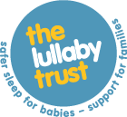

Visit the Lullaby Trust for advice on safer sleeping guidelines at [www.lullabytrust.org.uk](http://www.lullabytrust.org.uk) This information can be used to share with parents and carers in Early Years’ settings, hospitals, during home visits and in a variety groups and play sessions.

* If you have information you think would be useful to share on future broadcast emails then please contact me through the LSCB email address below.

West Sussex Safeguarding Children Board

Location: West Sussex County Council, Room 12, Ground Floor, East Wing, Chichester, West Sussex, PO19 1RQ

Internal: 25296 | External: +443302225296

E-mail: [lscb@westsussex.gov.uk](mailto:lscb@westsussex.gov.uk)

Website: [www.westsussexscb.org.uk](http://www.westsussexscb.org.uk/)

Twitter: @WestSussexLSCB