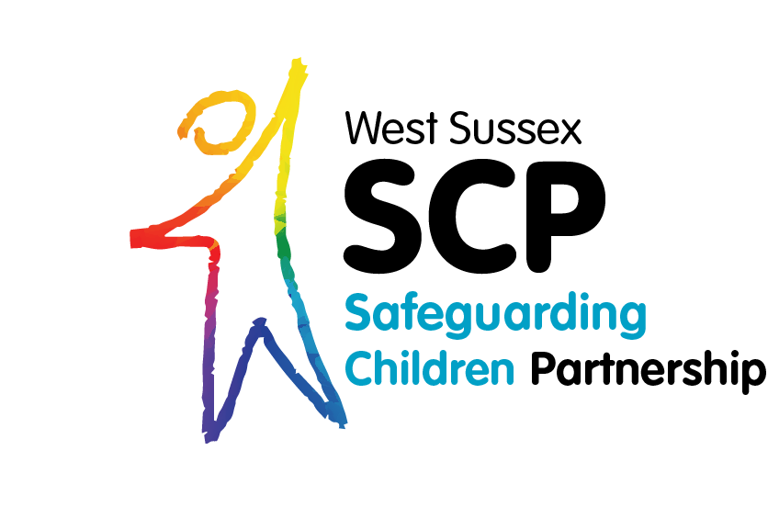

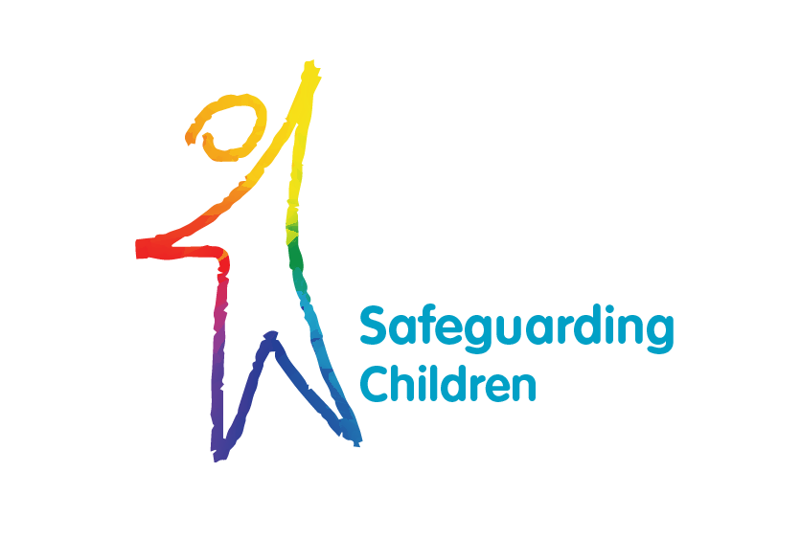

West Sussex LSCB wishes to acknowledge NHS West Sussex’s Neglect Risk Assessment and Portsmouth LSCB’s Development Checklist which elements of this tool
So What Do We Know? Next Steps?

Needs Analysis Template

Version Feb 2020

So What Do We Know? Next Steps? Needs Analysis Template Guidance

This template is designed to be used in conjunction with the age specific “day in my life” that frame the care needs of the following groups of children:-

- Day in my life – pre birth
- Day in my life – baby
- Day in my life – pre school aged child
- Day in my life – primary school aged child
- Day in my life – teenager
- Day in my life – child with a disability

And
- A chronology

These tools can be found at (add hyperlink)

The tools are excellent tools to gather an understanding of the lived experience of a child or children, identify patterns in a child’s history and review where improvements or deterioration in levels of care may have occurred.

In the development of these tools it was acknowledged that they are helpful to elicit a picture of the child’s lived experience, but they don’t ensure the professional draws together the information to develop an analysis. This template is designed to guide professionals, families and children in forming an analysis of need using a strength based approach.

Where age appropriate, they can be used with the child to help them describe the care they receive. Where professionals are working with parents or carers of pre birth or young babies, these tools can be completed with the parents to assist them to reflect on where their parenting is strong and other areas of care that aren’t as good. These tools can be found on the WSSCP webpage (Add hyperlink) and have been developed primarily to help professionals working with families where there are concerns about neglect. However, these tools may also be used to develop a picture of a child’s routines in other circumstances.

Summary of the day to day care of the child. (from use of the relevant “day in my life” and the chronology)

What is the child’s view of their situation?

What are the parents/carers and wider family’s views of the situation for the child?

What is this summary and the views gathered telling you about the child’s care and this family? What is working well, what are your worries? Using a Signs of Safety scaling how would you scale this child (0-10) and why?

What will the next steps be for:

- The parent, carers and wider family?

- The professionals

- The child? Where age appropriate

- When will this analysis be reviewed and by whom?

Manager’s or Safeguarding Lead oversight.

Name:
Date :

