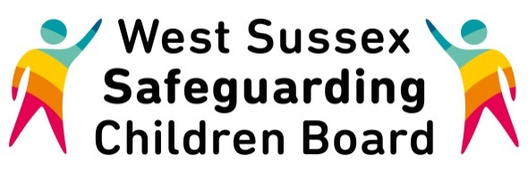

Nappy Sacks
Information and Safety Advice

Parents are being warned about the dangers of babies suffocating or choking on nappy sacks as the total deaths reached at least 16 across England and Wales during 2015.
Derbyshire has experienced 4 child deaths related to accidental suffocation by a nappy sack which prompted The Royal Society For The Prevention of Accidents (RoSPA) to seek to raise awareness of this serious issue again. All fatalities so far have involved babies under 12 months old and date back to 2001, according to research by RoSPA’s public health team, which compiles national data on nappy sack deaths.
Nappy sacks are thin, plastic sacks used to dispose of soiled nappies but many parents tend to store these items close to the cot or under the mattress for convenience when changing a baby at night. This can be dangerous if they are left within a baby’s reach while left unattended to sleep or play.
RoSPA is made aware of one to two nappy sack-related deaths a year and they know of at least 16 deaths in total. While most people are well aware plastic bags can be dangerous to children they don’t associate these risks with nappy sacks so are less likely to take the same safety precautions.
RoSPA’s campaign to educate parents on how to prevent unnecessary tragedies has been supported by the Department for Business, Innovation and Skills (BIS). The UK’s leading accident prevention charity is also working closely with Derbyshire County Council and Derby City Council.
RoSPA advice to parents and carers is to:
- Always keep nappy sacks and other plastic bags or wrapping away from babies and young children
- Never place nappy sacks in or near a baby's cot or pram
- Be aware nappy sacks are extremely light and flimsy and can be easily blown off a high surface or across a room by a draught or by opening or shutting a door
- Buy nappy sacks on a roll if possible.
More information, plus leaflets and posters on RoSPA’s nappy sack safety campaign are available at www.rospa.com/campaigns-fundraising/current/nappy-sacks
ROSPA are currently working closely with retailers to address the packaging issues and Nappy Sacks leaflets have been produced to highlight the issues with families. West Sussex has ordered some leaflets and these are available from the Public Health Resources team – contact Nicky Gale at Nicky.Gale@westsussex.gov.uk

