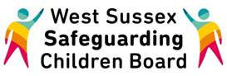

**WELCOME to the WSSCB Broadcast Email**

**May 2017**

**Reminder about the NEGLECT SURVEY!** This survey is for young people to complete alongside their worker. It is not appropriate for young people to be asked to complete this independently. It is focused on the young people’s experiences of support and does not ask for details about the self- harm. Click [**here**](https://haveyoursay.westsussex.gov.uk/childrens-safeguarding-unit/04f7ff44/) to go the survey. When a young person who has harmed themselves asks for help, we want to make sure they get the support they need. Your thoughts and experiences can help the LSCB improve this support.

Paper copies are available and can be requested by emailing <westsussexscb.org.uk>

**The closing date for this survey is Friday 30th June 2017**

**Safer Recruitment Training** is available through the **Family Information Service** for all staff that may be involved in recruitment of either staff and/or volunteers. The course will:

* Identify the key features of staff recruitment that deter or prevent the appointment of unsuitable people
* Consider policies and practice that minimise opportunities for abuse or ensure its prompt reporting
* Help participants  to review WSCC policies and practice in recruitment with a view to creating a safer culture

Please note that this is not intended to be a comprehensive workshop on staff recruitment and selection.

**To book a place on this course please email** [**family.info.service@westsussex.gov.uk**](family.info.service@westsussex.gov.uk) **quoting the course code IS094N.** **Please include role title and work base in your email.**

|  |  |  |
| --- | --- | --- |
| **Date** | **Time** | **Venue** |
| Friday 9 June 2017 | 09:00 - 16:30 | County Hall North, Horsham |

  Please note lunch is not provided.



It is coming up to the time of year where many children across different school years will be involved in **sitting a variety of** **exams**. These can cause worry and stress for the child or young person as well as concern for the parent or carer on how best to support their child during this often busy time. Click [here](https://www.nspcc.org.uk/services-and-resources/research-and-resources/pre-2013/beat-exam-stress/) to find out more about how young people can prepare, look after themselves during the exam season as well as support for parents.



Ensure you are familiar with the latest **Child Sexual Exploitation (CSE)** information by looking on the [LSCB website](http://www.westsussexscb.org.uk/professionals/helping-you-work/child-sexual-exploitation/), which includes the Risk Assessment document and Behaviour Chart, National Guidance, where to get help and other useful supporting documents.



To read the May edition of the **SEND Newsletter** click [here](https://content.govdelivery.com/accounts/UKWSCC/bulletins/18ade18). If you have any questions or would like to be added to the circulation list for this newsletter, please email [sarah.dimmock@westsussex.gov.uk](mailto:sarah.dimmock@westsussex.gov.uk).

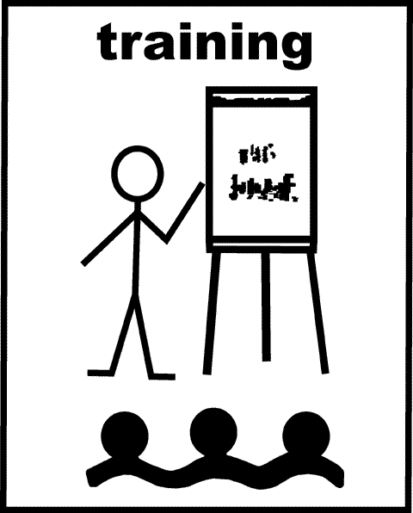

                   Here are some quick reminders of LSCB training coming soon:

* **Serious Case Review Briefing** on 15th June – click [here](https://www.westsussexcpd.co.uk/courses/bookings/c_detail.asp?cid=13497&iscancelled=0&curpage=&keyword=&ds=1&unconfirmed=&cs=&subid=&keystages=&locationid=&sdate=&searchcode=&asearch=&tutid=&estid=&sday=&smonth=&syear=&targetid=&cal=&calday=&calmonth=&calyear=&caldate=&submonth=&subyear=&list=&palist=&frompage=pathways.asp&a=&b=&c=&d=&s_leaid=&keyarea=&etid=&mtid=&isModule=&pid=20#sthash.L6P99E2H.dpbs) for full details and to request your place.
* **Child Sexual Exploitation Awareness** sessions on 26th June and 5th July COMING SOON TO THE LEARNING AND DEVELOPMENT GATEWAY! [WATCH THIS SPACE](http://www.westsussexscb.org.uk/professionals/training/training-calendar/)
* **Neglect** training on 11th July COMING SOON TO THE LEARNING AND DEVELOPMENT GATEWAY! [WATCH THIS SPACE](http://www.westsussexscb.org.uk/professionals/training/training-calendar/)

**Do you know what the LADO does and what is involved in this important role? Read on to find out…..**

**Allegations against staff within the children’s workforce in West Sussex**

All organisations providing services to children **must ensure** that those who work or volunteer with, on or behalf of children and young people are safe and competent to do so.

Equally, anyone that comes into contact with children or young people in their work has a **duty of care** to promote and safeguard their wellbeing.

The vast majority of people who work with children and young people act professionally and aim to promote the best outcomes for the children they work with, however at times the behaviour of staff can lead to harm or abuse and give rise to **allegations being made against them.**

Allegations may be substantiated, unsubstantiated, unfounded, false or malicious and there may be different perceptions of the same alleged incident.

**Who is responsible for the allegations against the children’s workforce process in West Sussex?**

The Local Authority Designated Officer (LADO) has overall responsibility for the management of allegations of abuse by adults who work with or volunteer with children.

* The LADO **provides advice**, in the form of consultation and specific guidance, liaising with Children’s Services, the Police and other regulatory bodies such as OFSTED and the Department for Education as needed in order to ensure a consistently fair and thorough process for both adult and child;
* The LADO **manages individual cases** and monitors the progress of cases for timeliness, thoroughness and fairness.

**When is it necessary to contact the LADO?**

The Pan Sussex Child Protection and Safeguarding Procedures provides guidance on managing cases of allegations that may indicate that a staff member **may not be suitable to work with children** in their current position, or in any other capacity.

A ‘staff member’ is a person over the age of 16 years whose work brings them into contact with children in their setting. It applies to all adults whether paid or working in a voluntary capacity (including agency workers) on or off site.

The procedures should be used in **ALL cases** in which it is alleged that a staff member has;

* Behaved in a way that has harmed a child or may have harmed a child;
* Possibly committed a criminal offence against or related to a child;
* Behaved towards a child or children in a way that indicates he/she would pose a risk of harm to children.

Information may also come to light about a staff members conduct **outside of the workplace** which may indicate a breach of professional conduct or may raise concerns about their suitability to work within the children’s workforce.

It is important that all allegations of abuse and breaches of professional conduct **are taken seriously** and considered with an **open and inquiring mind**.

**The employer should contact the LADO within one day of the incident happening or the allegation being made.** The employer must NOT commence an internal investigation before consulting with the LADO but should gather basic details such as was the employee actually working that day, did they potentially come into contact with the child(ren) and have any other potential witnesses come forward to corroborate or discount the **alleged incident**?

The LADO will consider the information and whether it meets the threshold for further consultation with Children’s Services and the Police

**What happens when I contact the LADO?**

Initially, you will be asked for some basic information to determine the next steps and whether it is felt that the **threshold** is met for the allegations management process.

The LADO will consider the information and whether it meets the threshold for further consultation with Children’s Services and the Police.

It remains the responsibility of the Police and Children’s Services to investigate allegations of abuse and conduct further assessments before the **employer starts to investigate an allegation**. Any such investigation without the guidance and advice of the LADO could potentially jeopardise a subsequent criminal investigation.

You may be asked to complete a referral form after your initial consultation with the LADO and this should be returned **electronically** as soon as possible.

Whilst each setting should have  a designated member of staff or child protection lead, **ALL staff have a responsibility** to report if they believe a member of staff is harming or is behaving in a manner which may potentially cause harm.

The LADO will provide guidance on what to do immediately and in the longer term, depending on the nature of the allegation and involvement of other agencies.

If directed by the LADO to internally investigate an allegation, actions should be conducted in a way that recognises the vulnerability of staff and seeks to protect them as far as possible from mistaken or false allegations, with the support of the settings’ own Human Resources team, whilst recognising that the **need to assess and manage the risk** they may pose to a specific child or children needs to remain of paramount importance.

Assistant LADO Contact:
Claire Coles
Tel: 0330 222 3339
Claire.Coles@westsussex.gov.uk
LADO Contact:
Lindsey Tunbridge-Adams
Tel: 0330 222 3339
Lindsey.Tunbridge-Adams@westsussex.gov.uk




**If you have any information that you would like to include in next month’s email bulleting please contact me**

Kind Regards,

Lucy Short

|  |
| --- |
| cid:image001.jpg@01D24F10.1F632CF0  **Lucy Short, Learning & Development Officer**  **West Sussex Safeguarding Children Board | Location:  3rd Floor (East Wing), County Hall, Chichester, PO19 1RQ Internal: 25508 | External: 033022 25508 | Mobile: 07850 537308**  [**lucy.short@westsussex.gov.uk**](mailto:lucy.short@westsussex.gov.uk) |