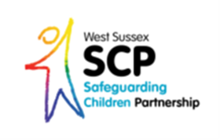

West Sussex Safeguarding Month
Ideas and suggestions to kick start your event!
Open up your organisation by offering a drop in event which highlights how you safeguard vulnerable adults and or children within your work
Ask your Designated Safeguarding Lead to carry out a masterclass with staff on a specific safeguarding topic

Set up a market place in your building with information about good safeguarding practice for people to take away.

Organise a “surgery” style drop in session for staff to come along to and ask questions they may have around effective safeguarding
Why not provide safeguarding fliers or leaflets to share with parents or carers
Offer information sessions to parents and carers to come along to, about safeguarding issues important to them…why not ask them in advance to make sure you are meeting their needs

Set up a training session for your staff to share best practice and or key messages on a specific topic that you feel is a priority within your own organisation such as child sexual exploitation or online safety

Thought of a way to promote Safeguarding Week that we haven’t? Why not share your ideas with us by emailing them to lucy.short@westsussex.gov.uk

The key purpose of the week is to provide a range of learning and development opportunities for staff and volunteers working with vulnerable adults and children in West Sussex, aimed at improving their safeguarding knowledge, skills and understanding, and promoting joint working.

