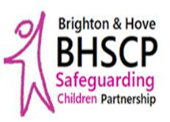
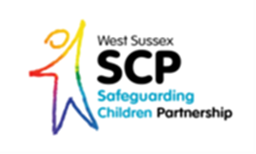
Friday 29th November 2019
Multi-Agency
Neglect Conference
Save the Date!
As part of Safeguarding Month, West Sussex and Brighton & Hove Safeguarding Children Partnerships will be holding a joint conference on Neglect. This will be take place in County Hall North, Horsham and is free to attend*
More information and details on how to request your place will be sent out shortly.
Please note that places are limited and confirmation of your place will be sent via the Learning & Development Gateway.
(Please forward on to colleagues and teams as appropriate)

*This event is free to attend however a charge will apply to those who do not turn up or cancel within 10 days of the Conference

