From the 1st of October 2019 the National Child Death Review Process has changed

Reasons for the Changes
Due to the statutory changes in the child death process, we have developed a Pan Sussex approach for reviewing all child deaths in line with the new guidance. These statutory changes are detailed within Working Together to Safeguard Children 2018. This enables a process, whereby every child’s death is systematically reviewed with the intention of learning what happened and why, and thus preventing future child deaths.

The child death review process covers children: a child is defined in the Act as a person under 18 years of age, regardless of the cause of death. Respect for the rights of children and their families is fundamental to the child death review process, and the family should be met with empathy and compassion and receive excellent communication and support. Therefore each parent of a child who dies will be offered a Key Worker/ Child Death Review Nurse.

What has Changed
When a child dies, in any circumstances, it is important for parents and families to understand what has happened and whether there are any lessons to be learned. The purpose of this statutory requirement is to develop a robust child death review process, which standardises reviews to ensure a uniform quality. The responsibility for ensuring child death reviews are carried out, is now held by Child Death Review Partners. These are defined as the Local Authority for the area in which the child died in England and any Clinical Commissioning Groups operating within that local authority area. The Child Death Review Partners must arrange to review all deaths of children normally resident in the local area and, if considered appropriate, for any non-resident child who has died in their area. The purpose of a review and/or analysis is to identify any matters relating to the death, or deaths, that are relevant to the welfare of children in the area or to public health and safety, and to consider whether action should be taken in relation to any matters. A National Child Mortality Database has been operational since 1st April 2019 and learning from all child death reviews will be shared with this database, which may in addition take into account information from other reviews in order to identify any trends or similarities with deaths. See Child Death Flow Chart below.

Impact on Professionals
As a professional, you may be asked to contribute towards the child death review process, depending on the circumstances of the child’s death. This would be through completion of an electronic form, attending a meeting or dialling into a meeting. Your information is crucial to the process, as it contributes to understanding the child’s journey, leading to more effective analysis and learning.

Completing Death Certificates
Death certificates should not be completed if there is any uncertainty about the cause of death and the death, and this should always be discussed with the relevant coroner for the 3 areas of Sussex. The doctor who signs the death certificate should have seen the child within 14 days of the death. If they have not seen the child, the coroner may still agree to the doctor signing a certificate if there is clear understanding of the cause of death.

For further guidance refer to BMA death certificate guidance.

Almost all unexpected deaths will be brought into hospital, but expected deaths for children on a palliative care regime at home or in a hospice setting would not usually be brought into a hospital setting. As stated in the guidance for unexpected deaths in most circumstances the child will be taken to a designated hospital to ensure the appropriate samples, if indicated, are taken and notification of the child’s death can be made.

Joint Agency Response (JAR)
This will be triggered when a child’s death is or the collapse leading to death would not have been reasonably expected to occur 24 hours previously. The flow chart below sets out the sequence of events that should occur according to the most recent statutory guidance.

Criteria for a JAR include the following:-
- The death is or could be due to external causes
- The death is sudden and there is no immediately apparent cause
- The death occurs in custody or where the child has been detained under the Mental Health Act
- Where the initial circumstances raise any suspicions that the death may not have been natural; or
- In the case of a stillbirth where no healthcare professional was in attendance

Child Death Review Meeting (CDRM)
This is the multi-professional meeting which takes place prior to the child death review partners CDOP (Child Death Overview Panel) review. At the CDRM meeting, all matters relating to an individual child’s death are discussed by professionals involved with the case. The CDRM should be attended by professionals who were directly involved in the care of that child during his or her life and in the investigation into his or her death. Attendance should not be limited to medical staff. It is the responsibility of the organisation responsible for the declaration of death to arrange the CDRM. The exception to this is when a Joint Agency Response has occurred, in which case responsibility defaults to the lead health professional. The Child Death Review Team will support this process and provide an electronic information pack. The minutes and a draft analysis form for each individual case must be sent from the CDRM, to the CDOP coordinator to inform the independent review at a CDOP.

CDOP
The review by the child death review partners is intended to be the final, independent scrutiny of a child’s death by professionals with no responsibility for the child during their life. The information gathered using all the standardised templates, may help child death review partners to identify modifiable factors that could be altered to prevent future deaths. The new system is designed to be more holistic so the CDOP panel can drill down and really understand each child’s journey, thus effectively analysing the presented information to determine any learning or themes to prevent future deaths.

eCDOP
The new online CDOP management system is accessible 24/7 and enables practitioners – particularly those who work shifts – to promptly submit the child death information. The notification form is set as a public document to enable anyone to submit a child death notification; however they will not be able to contribute further unless they are registered onto the system and receive an email from the eCDOP administrator. eCDOP is externally hosted to ensure compliance with new and emerging requirements, including GDPR.

The system will be set up using generic email accounts for each service. The user account can be shared amongst members of your team to allow for periods of annual leave and personnel change. However, in some cases practitioners may have personal logins. If you would like someone within your service to complete an eCDOP reporting form, forward the eCDOP request email, along with the log in details. When the practitioner logs into the system, the authentication code will automatically be sent to the original email address. This code must be forwarded to the practitioner to enable them to complete the form.
If you are not currently using a generic email account for eCDOP but would like to, please email the CDOP Co-ordinator at BHCCG.SussexCDRTeam@nhs.net who will be able to add your generic account and remove any personal ones.

In the notification and reporting forms there are free text boxes where you can enter as much information as possible about the child. We will send reporting forms (previously called Form B’s) to professionals and clinicians involved with the child. If you require support or advice completing the electronic forms, please contact the Child Death Review Team (contact details below)

Consent
There is no legal requirement for parental consent for this statutory process, however out of respect; the Child Death Review Nurse Team will contact every family to inform them that this process will be taking place. It is expected that all professionals will contribute by sharing information so the death can be thoroughly reviewed, ultimately supporting the family’s needs, part of which is to establish “why did my child die?”

Bereavement support.
The team will link in with families and provide support to them, liaising with bereavement services as necessary. We are aiming to signpost families and siblings to a Pan-Sussex bereavement support when procured.

Members of the Child Death Review Team
Designated Doctor for Child Deaths
A senior paediatrician, appointed by the CDR partners, who will take a lead in coordinating responses and health input to the child death review process, across Sussex. There are 2 paediatricians in this role currently.

Child Death Review Nurse Team
This is a Pan-Sussex team, comprising of a Child Death Review Lead Nurse, Child Death Review Specialist Nurses and Child Death Review Support Nurses. The team will provide support to families as well as being a link and a voice for them during the child death process. They will be instrumental in bringing the families’ voice to the CDRM.

Child Death Review Coordinator
A designated individual to whom all child death notifications and other data relating to deaths should be sent to. They will ensure effective management of Sussex eCDOP including pursuing outstanding agency reports when timescales for completion are exceeded. The coordinator will also ensure the effective running of CDOP meetings.

Contact Details -
Child Death Review Nurse Team & Child Death Review Co-ordinator Details:
01273 238872/ 01273 238808
Generic team email is Bhccg.SussexCDRteam@nhs.net

Child Death Review Flow Chart
Working Together 2018 Chapter 5 page 98. The new process as discussed in Working Together 2018, and further detailed in Child Death Review Statutory and Operational Guidance (England) 2018.

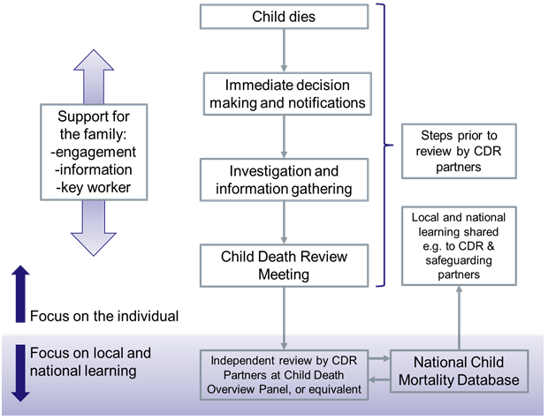

Child Death Review Statutory and Operational Guidance (England) Unexpected Child Death Process (page 13)

- Joint Agency Response Flowchart

