Dear Colleagues,

Child Sexual Exploitation (CSE) Awareness Day is tomorrow (Saturday 18 March) and all this week we have been sharing daily insights and useful resources for you on a range of topics related to child abuse and exploitation of young people.

Together we can stop CSE, and have a responsibility to say something if we see something. Please support our fight against CSE by sharing these important messages.

**Parents and Carers**

In our last daily instalment we focus on the role parents and carers can have safeguarding young people from the threat of child sexual exploitation.

Whilst being a looked after child is a significant risk factor, nationally, around 75% of young people affected by CSE live at home at the time of the exploitation.

Parents of sexually exploited children may experience terrible stress, isolation, fear, anger, shame and guilt. This can cause a huge strain on the parent and child relationship as well as marriages or partnerships leading to relationship breakdown. Siblings can also be adversely affected.

We know that parents want to be listened to, valued and considered in a respectful partnership with agencies to safeguard their child.  We have produced a short leaflet for anyone who may be concerned about their child.  Please [download a copy](http://ow.ly/ngAz309YmGK), and share with your colleagues.

**SPOT THE SIGNS**

Most parents understand the value of young people learning about themselves through new experiences, but also want to protect their child from harm.

There could be cause for concern if your child or a child you know is exhibiting **three or more** of the following warning signs of child sexual exploitation (CSE):

* **He or she becomes especially secretive and stops engaging with their usual friends.**
* **They may be associating with, or develop a sexual relationship with older men and/or women**
* **They may go** [**missing from home**](http://www.paceuk.info/for-parents/advice-centre/if-your-child-is-missing/) **– and be defensive about their location and activities, often returning home late or staying out all night**
* **They may receive odd calls and messages on their mobiles or social media pages from unknown, possibly much older associates from outside their normal social network**
* **They may be in possession of new, expensive items** (which they couldn’t normally afford, such as mobile phones, iPods or jewellery)

**HOW TO STAY SAFE ONLINE**

* One of the easiest ways to safeguard young people is through open and honest conversation. This is particularly pertinent where the young person has access to the internet and therefore could be at risk from online exploitation.
* Parents and carers are encouraged to be aware of their child’s online activity and familiarise themselves with the major signs of exploitation.  To help, West Sussex County Council has produced [A guide to keeping your child safe online](http://ow.ly/oVMH309Ymz9). This provides a range of advice, including tips on setting parental controls, being open with young people about their usage and encouraging responsible online behaviour.
* We have also produced a short click by click video to help parents and young people to set their [privacy settings](http://ow.ly/dfnv309YikZ) on all the major social media sites.

A wealth of information about child sexual exploitation, how to spot the signs and downloadable resources can be found on our campaign page [www.westsussex.gov.uk/CSE](http://www.westsussex.gov.uk/CSE).

Thank you for taking the time to explore the information bulletins this week. We hope you’ve found them useful and that they have helped to increase your awareness of child sexual exploitation, the signs to look out for, and how to access help and support if you have any concerns. Please get in touch if you have any feedback or questions about anything you’ve read.

Kind Regards,

Lucy Short

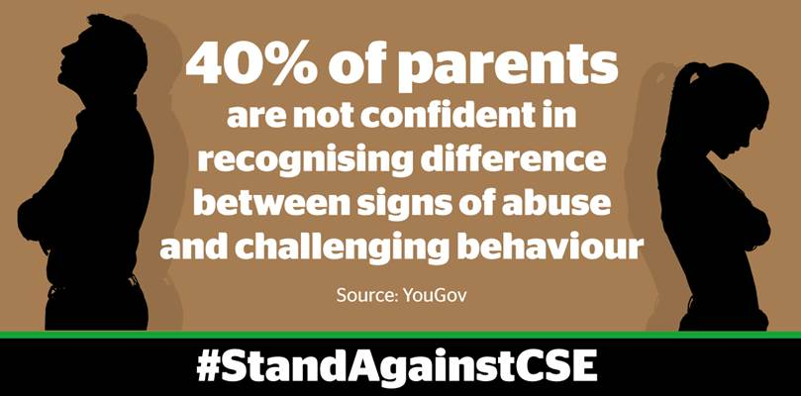

|  |
| --- |
| cid:image001.jpg@01D24F10.1F632CF0  **Lucy Short, Learning & Development Officer**  **West Sussex Safeguarding Children Board | Location:  3rd Floor (East Wing), County Hall, Chichester, PO19 1RQ Internal: 25508 | External: 033022 25508 | Mobile: 07850 537308**  [**lucy.short@westsussex.gov.uk**](mailto:lucy.short@westsussex.gov.uk) |

This e-mail and any attachments are confidential and intended solely for the persons addressed. If it has come to you in error please reply to advise us but you should not read it, copy it, show it to anyone else nor make any other use of its content. West Sussex County Council takes steps to ensure e-mails and attachments are virus-free but you should carry out your own checks before opening any attachment.