Dear Colleagues,

Child Sexual Exploitation (CSE) Awareness Day is Saturday 18 March and all this week we have been sharing daily insights and useful resources for you on a range of topics related to child abuse and exploitation of young people.

Child sexual exploitation is a crime with devastating and long lasting consequences for its victims and their families. We know that CSE is happening in West Sussex, and that it can happen to any child or young person, both on and offline, and that both victims and abusers can be both male and female.

Together we can stop CSE, and have a responsibility to say something if we see something. Please support our fight against CSE by sharing these important messages.

**Social Media**

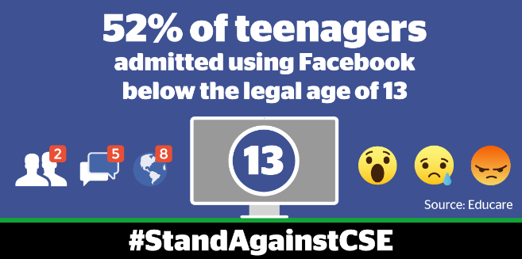

Today we focus on ways to help encourage young people to use social media safely. Did you know that in the UK alone, there are 2.5 million 13-17 year olds using Facebook?

Here are some tools and tips that can be shared with young people and their families to help them make more informed and safer choices when using social media and how to become more resilient to the threat of unwanted online attention.

Further information can be found at [www.westsussex.gov.uk/CSE](http://www.westsussex.gov.uk/CSE).

**AGE RESTRICTIONS**

* Nearly one-third of the world’s population now use the five largest sites: Facebook, Instagram, Snapchat, Twitter and Pinterest. But with technology developing at ever faster rates, it can be a minefield to determine which apps and social media sites are appropriate and safe for young people to use.

[Netaware](http://ow.ly/P3aN309XwUc) is a great resource for young people and parents & carers alike.  It is an easy to use website that provides information about popular apps and website including age restrictions.  
  
Below is a useful snapshot of the age restrictions for the most popular social media platforms, curtesy of Action for Children.

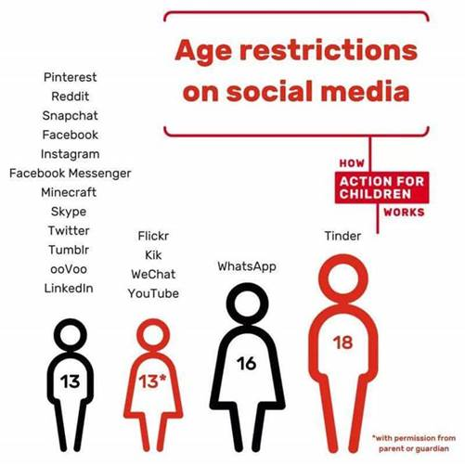

**SEXTING**

* Sexting (the sharing of sexual images online or via smartphones) has become common place among and between young people. To help young people keep control of their online chat; Childline has developed an app called [Zipit](http://ow.ly/P3aN309XwUc). The app contains funny images and one-liners as well as tips and ways for young people to report concerns or get help if needed.

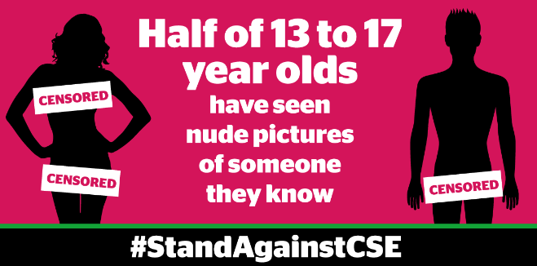

**HOW TO STAY SAFE ONLINE**

* Another threat to young people is online exploitation. This involves children being manipulated, coerced or blackmailed into sharing sexual imagery or engaging in sexual activity streamed via the internet.  Often starting in online chat rooms or social media sites, young people are identified and groomed by perpetrators, many of whom impersonate other young people to avoid raising suspicion.  ThinkUKnow has a wealth of information including advice about how to [reporting issues](http://ow.ly/oCuH309XwZu) to social media sites.
* West Sussex County Council has produced a short click by click YouTube video offering advice on [how to set privacy settings](http://ow.ly/oCuH309XwZu) on popular social media sites.
* Parents and carers are encouraged to be aware of their child’s online activity and familiarise themselves with the major signs of exploitation.  West Sussex County Council has produced [A guide to keeping your child safe online](http://ow.ly/QjiY309Xx3A). This provides a range of advice, including tips on setting parental controls, being open with young people about their usage and encouraging responsible online behaviour.

Look out for tomorrow’s broadcast, which focuses on the role parents and carers can have safeguarding young people.

Kind Regards,

Lucy Short

|  |
| --- |
| cid:image001.jpg@01D24F10.1F632CF0  **Lucy Short, Learning & Development Officer**  **West Sussex Safeguarding Children Board | Location:  3rd Floor (East Wing), County Hall, Chichester, PO19 1RQ Internal: 25508 | External: 033022 25508 | Mobile: 07850 537308**  [**lucy.short@westsussex.gov.uk**](mailto:lucy.short@westsussex.gov.uk) |