Child Sexual Exploitation (CSE) Awareness Day is Saturday 18 March and all this week we have been sharing daily insights and useful resources for you on a range of topics related to child abuse and exploitation of young people.

Child sexual exploitation is a crime with devastating and long lasting consequences for its victims and their families. We know that CSE is happening in West Sussex, and that it can happen to any child or young person, both on and offline, and that both victims and abusers can be both male and female.

Together we can stop CSE, and have a responsibility to say something if we see something. Please support our fight against CSE by sharing these important messages.

**Sa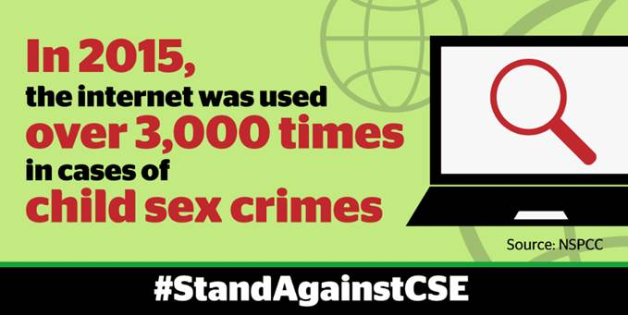fer Internet Usage**

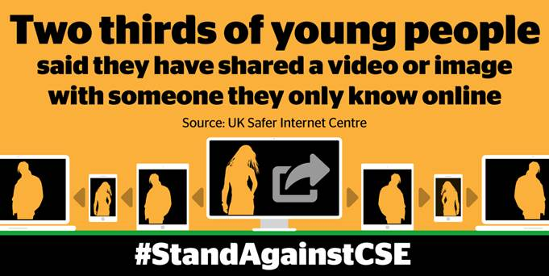

Today we focus on ways to encourage young people to use the internet safely. Whilst the internet can undoubtedly be a great source of information and provide exciting opportunities for young people to find out about the world around them, it also poses risks to them and is a place where inappropriate online behaviour can occur.

There are a range of tools available on our campaign page [www.westsussex.gov.uk/cse](http://www.westsussex.gov.uk/cse) to help young people become more resilient to the threat of unwanted online attention, grooming and exploitation.

**ADVICE FOR PARENTS AND CARERS**

* Families often think they know exactly what their kids get up to online, and that they understand all the apps and sites their kids use. But with technology changing every day, that's not always the case.  Download and share our [online safety guide](http://ow.ly/8LZJ309TTqB) and [leaflet for parents and carers](http://ow.ly/RhkI309TTAy).
* West Sussex County Council have also produced a short YouTube video advising [how to set privacy settings](http://ow.ly/VePN309TTFc) on popular social media sites.
* *Did you know you can* [*book an internet-safety appointment*](http://ow.ly/V9Bf309TWkE) *with an NSPCC-trained O2 Guru*? The NSPCC have partnered with O2 to help parents and carers keep young people safe online. Simply book an appointment online, take your devices with you and they'll be happy to answer your questions and set up your devices with parental controls.

**WSCC GUIDE TO STAYING SAFE ONLINE**

* For more information and how-to guides, visit [www.westsussex.gov.uk/campaigns/staying-safe-online](http://www.westsussex.gov.uk/campaigns/staying-safe-online) where you can find out ways to keep your whole family safe online.

If you have any questions about any of the above, please contact WSCC Community Officer, Francesca Blow at [Franscesa.Blow@westsussex.gov.uk](mailto:Franscesa.Blow@westsussex.gov.uk).

Look out for tomorrow’s broadcast, which focuses on social media.

Kind regards,

Lucy Short

|  |
| --- |
| cid:image001.jpg@01D24F10.1F632CF0  **Lucy Short, Learning & Development Officer**  **West Sussex Safeguarding Children Board | Location:  3rd Floor (East Wing), County Hall, Chichester, PO19 1RQ Internal: 25508 | External: 033022 25508 | Mobile: 07850 537308**  [**lucy.short@westsussex.gov.uk**](mailto:lucy.short@westsussex.gov.uk) |

This e-mail and any attachments are confidential and intended solely for the persons addressed. If it has come to you in error please reply to advise us but you should not read it, copy it, show it to anyone else nor make any other use of its content. West Sussex County Council takes steps to ensure e-mails and attachments are virus-free but you should carry out your own checks before opening any attachment.