Dear Colleagues,

Child Sexual Exploitation (CSE) Awareness Day is Saturday 18 March and all this week we will be sharing daily insights and useful resources for you on a range of topics related to child abuse and exploitation of young people.

Child sexual exploitation is a crime with devastating and long lasting consequences for its victims and their families. We know that CSE is happening in West Sussex, and that it can happen to any child or young person, both on and offline, and that both victims and abusers can be both male and female.

Together we can stop CSE, and have a responsibility to say something if we see something. Please support our fight against CSE by sharing these important messages and resources.

**Schools Resources**

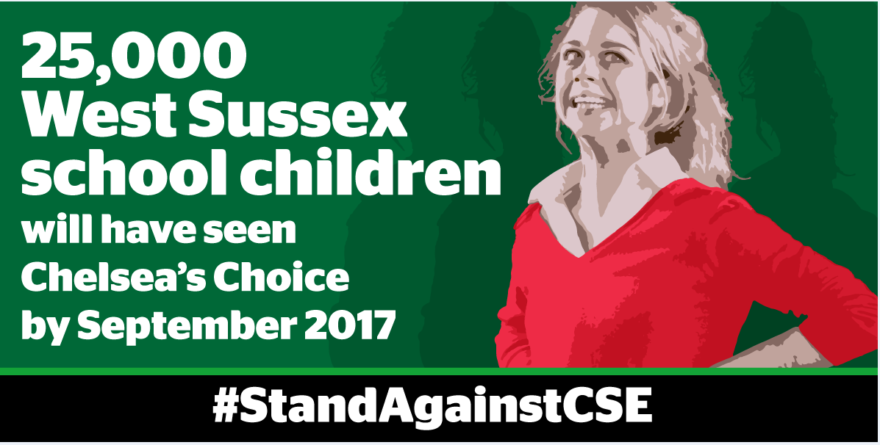

Today we share information about the wealth of resources available to schools and teaching professionals and an update on our investment in the CSE awareness raising play **Chelsea’s Choice**, which has been offered free to all secondary schools and alternative provision centres across the county.

**CSE SCHOOLS PACK**

* A comprehensive schools CSE pack was sent to all head teachers and safeguarding leads in the autumn term. This includes a link to an [online quiz](https://haveyoursay.westsussex.gov.uk/policy-and-comms/healthy-relationships-online-safety-consent/) for pupils, which can be completed during Relationships & Sexuality Education (RSE) or tutor time.  The quiz and online copies of all the resources found in the pack can be downloaded directly from our campaign page [www.westsussex.gov.uk/CSE](http://www.westsussex.gov.uk/CSE).

**IN-SCHOOL OPPORTUNITIES**

* We are now halfway through a six week tour of Chelsea’s Choice.  The play is based on a true story of ‘Chelsea’ who was groomed, exploited and trafficked across the country by a male she considered to be her boyfriend.  A professionals showing of Chelsea’s Choice is scheduled for mid-May so please contact [claire.clilverd@westsussex.gov.uk](mailto:claire.clilverd@westsussex.gov.uk) if you are interested in attending the session.
* Schools that have had a performance of Chelsea’s Choice have also taken part in a CSE survey to help us better understand young people’s understanding of the issue.
* The charity Asphaleia has started it’s five year project for children living in West Sussex. The project (funded by the Big Lotto) will provide:
* 1-1 intervention for identified children at-risk of CSE
* preventative workshops for year 6 children in pilot sites,
* support for parents
* mentoring/group work with young people at risk of becoming perpetrators of CSE.

If you would like your school to be considered for the second and subsequent phases of prevention workshops, please contact [jez.prior@westsussex.gov.uk](mailto:jez.prior@westsussex.gov.uk)

**LSCB TRAINING FOR SCHOOLS**

[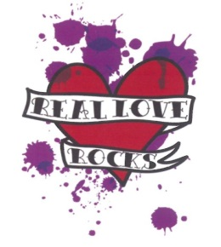](http://www.google.co.uk/url?sa=i&rct=j&q=&esrc=s&source=images&cd=&cad=rja&uact=8&ved=0ahUKEwiyrI7VrsTSAhWTzRoKHRrtAIgQjRwIBw&url=http://www.itsnotokay.co.uk/what-is-it/keep-safe/&psig=AFQjCNF01JRGVqZWWQkeUXCA8C7oraKwiQ&ust=1488975105370255)

* The Real Love Rocks programme is a West Sussex Safeguarding Children’s Board training course delivered by Children’s Charity Barnardo’s. It costs just £95 per teacher/staff member attending and provides all the tools and resources required to help you deliver the sessions in school.
* The primary version of Real Love Rocks (suitable for KS2) is a gentle introduction into themes such as respect, healthy relationships (plutonic and romantic/sexual) and boundary setting.
* If you would like more information about either the KS2 or KS3 versions of Real Love Rocks, please visit the [West Sussex Learning Gateway](http://www.westsussexcpd.co.uk/) where you can view available courses, or contact [lucy.short@westsussex.gov.uk](mailto:lucy.short@westsussex.gov.uk)

**Don’t forget…**

* The West Sussex [CSE screening and risk assessment tool](http://www.westsussexscb.org.uk/wp-content/uploads/LSCB-CSE-Risk-assesment-Document-and-Behaviour-Chart-version-2.1-Feb17.docx) has recently been revised and is available for use by any professional who has concerns about a child or young person. Copies can also be downloaded via the LSCB website

Look out for tomorrow’s broadcast, which focuses on Safer Internet Usage.

Kind Regards,

Lucy Short

|  |
| --- |
| cid:image001.jpg@01D24F10.1F632CF0  **Lucy Short, Learning & Development Officer**  **West Sussex Safeguarding Children Board | Location:  3rd Floor (East Wing), County Hall, Chichester, PO19 1RQ Internal: 25508 | External: 033022 25508 | Mobile: 07850 537308**  [**lucy.short@westsussex.gov.uk**](mailto:lucy.short@westsussex.gov.uk) |