Dear Colleagues,

Child Sexual Exploitation Awareness Day is Saturday 18 March and all this week we will be sharing daily insights and useful resources for you on a range of topics related to child abuse and exploitation of young people.

Child sexual exploitation (CSE) is a crime with devastating and long lasting consequences for its victims and their families. We know that CSE is happening in West Sussex, and that it can happen to any child or young person, both on and offline, and that both victims and abusers can be both male and female.

Together we can stop CSE, and have a responsibility to say something if we see something. Please support our fight against CSE by sharing these important messages and resources.

A full range of resources can be found at [www.westsussex.gov.uk/CSE](http://www.westsussex.gov.uk/CSE)

**Training & Guidance:**

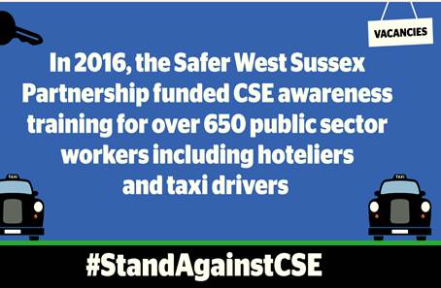

Today we share the latest updates and information about training and professional guidance.

**NATIONAL AND LOCAL procedures and guidance UPDATE (FOR FRONT LINE STAFF)**

* The Department for Education published their [CSE: Definition and Guide for Practitioners](http://ow.ly/ggZS309QX7s) last month.
* Local CSE procedures are being finalised and will be reissued shortly, in the meantime here’s the \***NEW**\* [local flow chart](http://ow.ly/Nm6e309QXgv), which includes details of risk categories and is also available to download via the learning gateway.

**CSE SCREENING TOOL**

* In order for us to know and understand our profile of children who have been identified at risk of CSE it is vital that the [CSE Screening and Risk Assessment Tool](http://ow.ly/GRA1309QXnt) is utilised so please ensure you do complete and share this tool as directed if you are concerned about any child being at risk.

**NEW INVESTMENT**

* A series of training sessions have already been completed by frontline staff and those working with young people.  However the community are also our ‘*eyes and ears’* and can play an important part in helping to tackle CSE.

The children’s charity Barnardo’s has received partnership funding to run awareness-raising sessions with key industries and members of the community. This will be used for training parks & foreshore officers, leisure centre staff and those working in coffee shops, fast-food outlets, bowling alleys, amusement arcades, cinemas and other popular places will be offered free training.

If you have any ideas about who else should be included in the free training sessions, please email your suggestions to [claire.clilverd@westussex.gov.uk](mailto:claire.clilverd@westussex.gov.uk)

**INTRODUCING**

* You may also be aware that Jan Hawkins has taken on a new role as the Missing and Exploitation Coordinator.  If you have any queries regarding the new procedures or the screening tool, contact Jan at: [CSEHUB@westsussex.gcsx.gov.uk](mailto:CSEHUB@westsussex.gcsx.gov.uk)

Look out for tomorrow’s broadcast, which focus on  Schools Resources.

Kind Regards,

Lucy Short

|  |
| --- |
| cid:image001.jpg@01D24F10.1F632CF0  **Lucy Short, Learning & Development Officer**  **West Sussex Safeguarding Children Board | Location:  3rd Floor (East Wing), County Hall, Chichester, PO19 1RQ Internal: 25508 | External: 033022 25508 | Mobile: 07850 537308**  [**lucy.short@westsussex.gov.uk**](mailto:lucy.short@westsussex.gov.uk) |