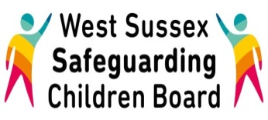
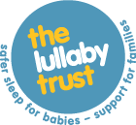

Basic Awareness of Safer Sleeping Messages for Babies Workshop (6 months and under)

Tuesday 7th March 2017
2pm – 4pm

County Hall, Chichester

This workshop is for practitioners and foster carers who have not previously received safer sleeping training and will include;

- The safest place for babies to sleep
- The safest sleep positions for babies
- Those babies more at risk of sudden infant death syndrome
This workshop is co-delivered by The Regional Development Officer from the Lullaby Trust and a Specialist Nurse for Safeguarding Children

Click here to request your place

