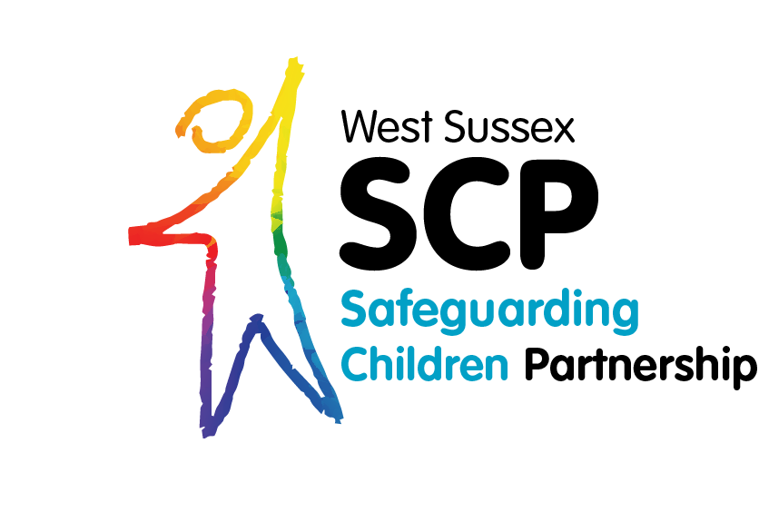

West Sussex LSCB wishes to acknowledge NHS West Sussex’s Neglect Risk Assessment and Portsmouth LSCB’s Development Checklist which elements of this tool
So, what do we know and what will we do?

Needs Analysis Template

Version 2. Oct 2023
So what do we know and what will we do?
Needs Analysis Template Guidance

This template is designed to be used in conjunction with the age specific “day in my life” that frame the care needs of the following groups of children:-
- Day in my life – pre-birth
- Day in my life – baby
- Day in my life – pre-school aged child
- Day in my life – primary school aged child
- Day in my life – teenager
- Day in my life – child with a disability

And
- An impact chronology
- Neglect Matrix
- Parent/ Child Observation (Children Social Care tool)

These tools can be found at:
Resources and Tools to Support Workers in Identifying and Tackling Neglect - West Sussex SCP

The tools will aid you to gather an understanding of the lived experience of a child or children, identify patterns in a child’s history and review where improvements or deterioration in levels of care may have occurred.

In the development of these tools, it was acknowledged that they are helpful to elicit a picture of the child’s lived experience, but they don’t ensure the professional draws together the information to develop an analysis. This template is designed to guide professionals, families and children in forming an analysis of need using a strength-based approach.

Where age appropriate, they can be used with the child to help them describe the care they receive. Where professionals are working with parents or carers of pre-birth or young babies, these tools can be completed with the parents to assist them to reflect on where their parenting is strong and other areas of care that aren’t as good, they can also be completed through observation of the child’s care.
It is important to consider your approach to capturing the best information to inform you analysis and ensure you adapt practice accordingly. For example: using games, visual aids or observation for example.

What is the family’s view about the worries you have raised around neglect?
Prompting Questions:
- Do the family understand what neglect means and do they recognise that their children’s basic needs are not being met?
- Where do they feel they are on the neglect matrix?
- Which type of neglect do they feel they identify with?

Analysis of the Neglect Tools completed with the family.
Prompting Questions:
- What tools have you used to inform your analysis?
- What is the neglect toolkit telling you about the children’s experience?
- Are there any patterns you can see: strengths and worries?
- Name and explain the worries around the impact on the child/ren

What will the next steps be to address the worries/impact on the child/ren:

- The parent, carers and wider family?

- The professionals

- The child? Where age appropriate

NB: Ensure these are embedded within the child’s plan

- When will this analysis be reviewed and by whom?

Manager’s or Safeguarding Lead oversight.

Name:
Date :

