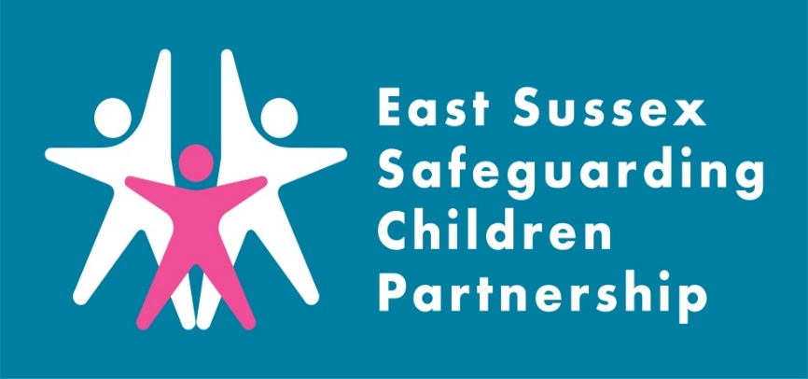
Introduction:
What is a Local Child Safeguarding Practice Review?

A Local Child Safeguarding Practice Review (LCSPR) is a locally conducted multi-agency review in circumstances where a child has been abused or neglected, resulting in serious harm or death, and/or there is cause for concern as to the way in which agencies have worked together to safeguard the child.

The purpose of a review is to establish whether there are lessons to be learned about the way in which local professionals and agencies work together to safeguard children; identify what needs to be changed and, as a consequence, improve inter-agency working to better safeguard and promote the welfare of children.

‘Neglect’ LCSPR
Learning Briefing

The East Sussex Safeguarding Children Partnership (ESSCP) undertook a Local Child Safeguarding Practice Review (LCSPR), following a serious safeguarding incident in 2021, involving the neglect of a large group of siblings. In early 2022, the partnership also conducted ‘rapid reviews’ of agency information on two further separate safeguarding incidents, where there was significant neglect of children in the family.

The publication of the ‘Family CC’ LCSPR report is delayed due to criminal procedures. To ensure that learning is shared as soon as possible this briefing will set out the headline learning from this review.

The ESSCP Case Review Group felt it was important for this learning briefing to also reflect on the two rapid reviews (that did not go on to become full LCSPRs) as the cases were so similar. In all the cases the children were immediately placed in police protection, following attendance by emergency services at the home, due to the presentation of the children and squalid conditions of the family home.

Other similarities included:
- There were previous concerns about neglect, with children in each of the three families previously subjects of child protection plans and/or children in need plans. All plans had ceased at the time of the serious safeguarding incident.
- Many of the children were missing education and/or were electively educated at home (EHE) at the time of the serious incident.
- Many of the children had additional learning, social and developmental needs. In one case a child had a diagnosis of ASD and was non-verbal.
- There was poor parental engagement across multiple services. In two of the three cases parents were identified as ‘resistant/avoidant’ parents.
- In all three cases, attempts to visit the family at home had been cancelled, or professionals were only able to undertake ‘doorstep visits’, due to Covid-19 related reasons by the families. This had made accurate assessments of the home environment very difficult.
- In all three cases, learning was identified around ‘unseen men’, as the father/partner was often overlooked in the assessment of the family - either as a risk factor or as someone who could protect and nurture the child/ren.

Key learning:
The following learning points were identified in the Partnership Review process.
- Working with ‘highly resistant’ parents
The nature of child in need or child protection planning requires that parents engage in assessments and plans in order to reduce risks to the children. The review identified that professionals struggled to work with parents who were resistant, and on occasions duplicitous. Working with such parents is always complex and difficult, but they are not unique.
The review suggested a need for a stronger focus on the ‘lived experience of the child’: identifying what it is like for children to live in the household; assessing parents’ capacity to empathise and understand the child’s experience; and ensuring that there is sufficient contact with the child to enable an understanding of the life the child was living.
- Safeguarding children who are EHE in the context of neglectful parenting
A family’s decision to educate children at home makes it significantly more difficult for agencies to have access and to be able to directly hear their voice. It also makes it less likely that children would have the opportunity to meet with a professional that they could trust, to talk about their home experiences.
Current EHE legislation does not give powers to the local authority to insist on seeing EHE children or hearing their voice. It also does not give powers to insist on visiting the home or meeting with family. There is work at a national level to consider how the law can be further developed to better protect children who are EHE.
A significant feature of the Family CC LCSPR was that the elective home education of the children was occurring in the context of neglectful parenting. The review identified that current local approaches to assessing neglect needs to place greater focus on the extent to which the education provided is fully meeting their ‘basic emotional, social and educational needs’.
- Relevance of neglect and/or abuse of animals when assessing risks to children
Research has shown that neglect/ abuse of animals is a known risk factor for abuse or neglect of children. If a child is cruel to animals, this may be an indicator that serious neglect and abuse have been inflicted on the child. There is also some evidence that households, where animals are abused, are often more violent and furthermore that where animals are abused there may be risks of physical harm to the children.
Practice in this case suggested that the links between animal abuse and risks to children were not well known and that there is little joint working between the RSPCA and local safeguarding services. The review asks if this is an area the ESSCP should develop.
- Relevance of history when screening for service delivery
The Family CC reviewer found that professionals were unaware of significant elements of the family history, despite the family being well known to a range of agencies and the children having been the subject of child protection plans on previous occasions.
In this case, when agencies were screening referrals, or initiating assessments, they were reliant on the information provided by either the referrer or the family. Reasons for this varied, in many cases the information was held by the agency but could not be quickly or easily obtained. Sometimes there was information held on the system regarding one child but there was no mechanism for cross-referencing that with other children, even though they were all living at the same address. It was acknowledged that much of the information was held in child protection conference records, but these were not considered to be easily accessible.

This is a serious limitation as it is well known that a person’s past actions are a useful predicator of future activity. Mother had clearly shown, in the past, aspects of disguised compliance and resistance to change, and perhaps if there had been better access to previous records this behaviour might have been better understood.
- Role of voluntary sector agencies in providing support to vulnerable families
The Family CC review identified considerable support was provided to the family by local voluntary organisations, who had relevant information they could have shared with the professionals who were working with the family. There was however limited communication and a degree of confusion on both sides as to their roles and responsibilities.
Direct communication about mutual roles and responsibilities may have led to better outcomes for the children. The review recommends that the ESSCP considers how better to involve voluntary sector agencies in the multi-agency safeguarding process.
- The cumulative risk of harm when risk factors are present in combination or over time
The National Safeguarding Practice Review Panel’s second Annual Report published in May 2021 states that ‘the recognition of cumulative neglect and its impact continues to be a key challenge for practitioners’ nationally. There is a danger when working with cases of long-term neglect and/or emotional harm that agencies wait for a serious one-off incident to happen to provide evidence to each other, or to the courts, that the children are suffering significant harm on a given day. With neglect and emotional harm, a number of smaller issues or concerns when collated may show significant harm over time. There is a cumulative impact on children of care that dips just above and then below ‘good enough’ on a regular basis. Assumptions can be made about the resilience of children in cases where the concerns are chronic and long term.
It is essential that patterns over time are considered when any professional is considering the threshold for a referral or an escalation of a professional disagreement when there are concerns that children are not being safeguarded. When there is a clear case of reoccurring risks, the likelihood of ongoing harm to the children needs to be the focus of action taken, rather than professionals feeling helpless due to what they see as the burden of needing to prove that harm is present at a given point on a given day.

Recommendations:
The Family CC LCSPR identified six recommendations to strengthen safeguarding practice:
Recommendation 1: The ESSCP and all agencies review the training and support processes available for professionals working with resistant parents ensuring that they place sufficient focus on understanding the relevance of family history and the lived experience of the child. Furthermore, the Partnership to request that health agencies consider the issue of fabricated illness in this context and to require all health professionals to ensure that when assessing the medical needs of the child they do not rely solely on evidence reported by parents.
Recommendation 2: The ESSCP should request that children’s social care (CSC) adapt its audit processes so that any child protection plan that ends after three months (at the first review), is audited by the Safeguarding Unit Operations Manager. Furthermore, that CSC develop a system whereby when a child protection plan ends when the allocated social worker has recommended its continuation, this should be reviewed by managers.
Recommendation 3: ESSCP to review the practice and procedures regarding core groups to require that there be consideration by the core group of whether the child protection plan should continue prior to every review conference meeting.
Recommendation 4: ESSCP to develop the neglect policy and training for all professionals to consider the needs of children who are EHE. This to include the requirement that there be consideration of whether the parents can provide EHE effectively; and that if there are concerns, this could trigger an assessment of parenting skills with an assumption that a failure to provide suitable EHE is neglect of basic emotional, social, and educational needs.
Recommendation 5: ESSCP to request all agencies to review their recording systems (including IT systems) to ensure that workers screening referrals/and or starting assessments are able to be more aware of the wider family history and any previous agency involvement.
Recommendation 6: ESSCP to consider how to better involve voluntary sector agencies in the multi-agency safeguarding processes.
Recommendation 7: ESSCP to consider, as part of their routine audit programme, whether multi-agency safeguarding assessments have sufficient focus on fathers and other significant males.

Action taken since the review:

Since the reviews have been completed, the ESSCP has set up a ‘Neglect & Poverty’ Task and Finish Group, which is made up from a range of representatives from multi-agency partners. It will be the responsibility of the Task and Finish Group to:
- evaluate and review the current Neglect Strategy and training offer
- update and launch the revised multi-agency Neglect Toolkit and Neglect Matrix
- develop the multi-agency Poverty Practice Framework, to support the prevention of safeguarding issues as a result of poverty
- Explore Pan-Sussex approaches to Neglect and Poverty Strategies

Learning for practice:
The ESSCP invite you to discuss the issues raised in this briefing in your team meetings or during group supervision. We encourage your responses to be included in your team minutes and forwarded to the safeguarding lead within your organisation.

Points for discussion:
- What learning did you expect, or what surprised you about learning from this review?
- How curious are you about the lived experience of children who are electively home educated?
- How do you approach working with parents who are resistant or aggressive towards professionals?
- When did you last undertake training on neglect? What do you think might have changed since you last undertook training?
- How do you consider the evidence of domestic abuse in the past, present, and likelihood of abuse reoccurring?
- When was the last time you used the Pan Sussex Child Protection and Procedures Manual?
Useful Links:

Pan Sussex Procedures
When was the last time you used the Pan Sussex Safeguarding and Child Protection Procedures? Did you know you can sign up to alerts for when the manual is updated.

Multi-agency training
Our new platform for learning and training in East Sussex is now live! Courses may be delivered face to face or virtually so make sure you check the course details when booking. Information on all courses available can be found on the East Sussex County Council Learning Portal

Contacting the Single Point of Advice (SPoA)
Details on contacting SPoA can be found here: Contacting the Single Point of Advice (SPoA) | East Sussex County Council

ESSCP Contact
Details about the Partnership and its work can be found at www.esscp.org.uk. Follow the ESSCP on twitter for the latest safeguarding news in East Sussex @EastSussexLCSB

The ESSCP can be contacted on ESSCP.Contact@eastsussex.gov.uk or 01273 481544

