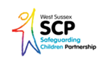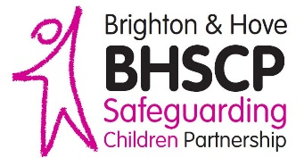****

**Dispute Resolution & Escalation Protocol**

**November 2018**

Any professional who is unhappy about a decision/action should contact the professional who made the decision/took the action to express their views and concern and discuss/explore the basis of that decision. Be specific and evidence based as to what the difference of opinion is about and how this effects the outcomes for the child.

Records of discussions must be maintained by all the agencies involved.

**Stage 1:**

**Professional to Professional**

**Stage 2:**

**Manager to Manager**

If you are unable to resolve differences through discussion and/or meeting within a time scale, which is acceptable to all partiers, your disagreement must be addressed by more experienced / more senior staff

Raising the issue with your line manager can be done in written or verbal format but there must be a written record of the issue raised, the action taken and the outcome for the child.

**Stage 3:**

**Senior Manager**

**to Senior Manager**

If agreement cannot be reached following discussions between the 'first line' managers the issue must be referred without delay through the line management to the equivalent of Head of Service / detective inspector / head teacher / Named Doctor or Nurse.

These two managers must attempt to resolve the professional differences through discussion and focus on outcomes for child.

**Inform the WSSCP at the stage using the Escalation Template**

In the unlikely event that the issue is not resolved by the steps described above and serious professional disagreements remain unresolved /or the discussions raise significant policy issues, the matter should be raised with the professional leads for safeguarding and child protection within the agencies involved and include the senior child protection manager / Designated Doctor or Nurse.

For information on:

* Dissent with decision to call a Child Protection Conference
* Professional Dissent at Child Protection Conference
* Dissent regarding the Implementation of the Child Protection Plan

See [Pan-Sussex Safeguarding Procedures: Resolution of Professional Disagreements](https://sussexchildprotection.procedures.org.uk/skzq/complaints-and-professional-disagreements/resolution-of-professional-disagreements)

**Stage 4:**

**Professional leads for Safeguarding**

**Stage 6:**

**Escalation to Secretary of State**

If the Safeguarding Children Partnership Independent Scrutineer considers that the leadership arrangements are weak or malfunctioning and all attempts at resolution have failed, legislation allows the Secretary of State to take enforcement action against any agency that is not meeting its statutory obligations as part of local safeguarding arrangements.

**Stage 5:**

**Escalation to SCP**

In the unlikely event that the steps outlined above do not resolve the issue, and / or the discussions raise significant policy/procedure issues and / or a number of similar concerns or disagreements have been recorded, the matter should be referred to the Safeguarding Children Partnership Independent Scrutineer to determine the appropriate process for resolution. This will include raising the issue with the Directors / Chief Executives of the three Safeguarding Partners.