**Welcome to the**

**WSSCP Email Bulletin**

**June 2021**



The newest edition of the Pan Sussex Briefing is available to read now and includes information and updates on a variety of topics including the bruising protocol for non-independently mobile children, young person’s substance misuse, and the flow chart for perplexing presentations/over medicalisation and fabricated or induced illness. To read the full briefing click on the link below:

<https://www.westsussexscp.org.uk/information-resources/newsletters-bulletins>



Ofsted have now published their monitoring visit report following an inspection of West Sussex Children’s Services on 18 and 19 May 2021. To read the report click on the link below:

<https://www.westsussex.gov.uk/news/ofsted-monitoring-visit-to-west-sussex-children-s-services/>

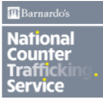

We are supporting the Stop Child Trafficking and Modern Slavery Campaign that takes place across this week (28th June – 4th July)

Child trafficking and modern slavery are child abuse. Many children and young people are trafficked into the UK from other countries including (but not exclusively) Vietnam, Albania and Romania. Children are also trafficked around the UK (NSPCC).

A range of resources are available to support practitioners and children in understanding and recognising and responding to child trafficking and modern slavery. These include leaflets and tips in several languages. Click on the link below to view these:

<https://www.westsussexscp.org.uk/trafficking-of-children-campaign-28th-june-4th-july>



**COMING SOON!**

Training on Child Protection Conferences and Core Groups is currently being updated and will be available to attend from September. This training has been developed with the support of a multi-agency working group to ensure the content is informative and relevant to all agencies attending a conference or core group. As with all WSSCP training, it will be available on the Learning & Development Gateway as well as on the [WSSCP Training Calendar](https://www.westsussexscp.org.uk/professionals/training/training-calendar). Watch this space!

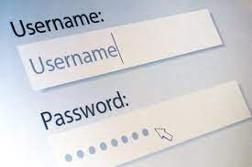

If you haven’t yet requested a username and password for the Professional Log In section of the WSSCP website, you can do so by emailing [WSSCP@westsussex.gov.uk](mailto:WSSCP@westsussex.gov.uk) . Please use you your work email address so that it is clear you are a professional and not a member of the public. Documents available on this closed section of the website include unpublished child safeguarding practice reviews, learning briefs and resources specifically for Neglect champions.



There is new eLearning available on Adverse Childhood Experiences (ACES) and early trauma. This training will provide you with an introduction to ACES and Early Trauma and the impact that this can have upon a child’s development and their response to stress. To view the full details of this course and to complete this learning click on the link below:

[Adverse Childhood Experiences (ACES) and Early Trauma eLearning](https://www.westsussexcpd.co.uk/courses/bookings/c_detail.asp?cid=24259&iscancelled=0&curpage=&keyword=ACES&ds=1&unconfirmed=&cs=&subid=&keystages=&locationid=&sdate=2/June/2021&searchcode=&asearch=&tutid=&estid=&sday=&smonth=&syear=&targetid=&cal=&calday=&calmonth=&calyear=&caldate=&submonth=&subyear=&list=&palist=&frompage=&a=&b=&c=&d=&s_leaid=&keyarea=&etid=&mtid=&isModule=99&pid=#sthash.rxnASaTU.CrrmdpdZ.dpbs)



If you have anything you would like to add to future editions of this email bulletin please send the details to

[Lucy.Short@westsussex.gov.uk](mailto:Lucy.Short@westsussex.gov.uk)

Kind Regards,

Lucy

Lucy Short

WSSCP Learning & Development Officer

West Sussex Safeguarding Children Partnership Business Team

Learning & Development Team

County Hall South,

Chichester

PO19 1RQ

03302225508

07850537308

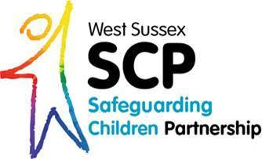

To find out more about ICON click on this link below:

<https://www.westsussexscp.org.uk/professionals/working-with-families/keeping-babies-safe-useful-information-and-icon>

