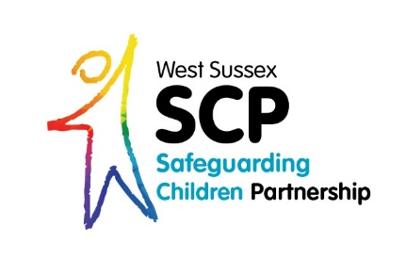
Welcome to the
WSSCP Email Bulletin
May 2021

There are new dates for a lot of sessions on the WSSCP Training Calendar, including Domestic Abuse Awareness, Domestic Abuse – The Impact on Children, Prevent, Recognising Racism. This training page is regularly updated with new dates and course information so check back regularly to make sure you’re not missing out! Click on the link below to find out more:
WSSCP Training Calendar

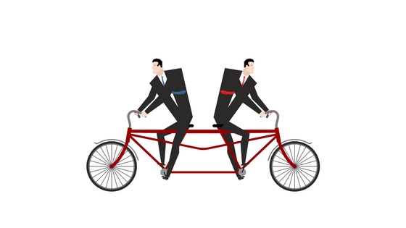
The WSSCP Escalation Policy is an important document to be aware of, whatever your role, level of responsibility or organisation. A key part of escalation involves the practitioner being professionally curious and providing challenge to a decision made by a different organisation to your own that you do not agree with. Professional curiosity is a critical skill to use in all aspects of your safeguarding practice and professional challenge is a healthy part of the safeguarding process with other professionals (as well as parents and carers). Effective safeguarding depends on an open approach and honest relationships between all agencies. Problem resolution is an integral part of professional cooperation and effective joint work to safeguard children. Ensuring the safety of children is the key consideration in resolving any professional disagreement.
The WSSCP is currently under review and will be available soon. In the meantime you can still access the current version by click in the links below.
- WSSCP Escalation page on the WSSCP website
- WSSCP Escalation Policy
- Attend training on Professional Curiosity
- View Learning Brief and 7 Minute Slides on Professional Curiosity

The Dadpad app was launched in West Sussex at the start of 2021 and is an excellent resource for new Dads and male carers. It is free for families to download in West Sussex and provides information on all things babies! Information includes how to keep baby safe, feeding your baby, safer sleeping, holding your baby, getting to know your baby and much more! Although called Dadpad, the information is also totally relevant to mums and female care givers, so don’t delay; share this information with the families you work with today! Simply download the app using Google Play or the Apple App store and enter your West Sussex postcode.

ICON has been active in West Sussex for just over a year and if you have been receiving these emails for a while you will be aware of ICON and how it can help new parents (with an emphasis on Dads and male carers). Abusive Head Trauma (AHT), previously known as Shaken Baby Syndrome, is a devastating form of child abuse.
The ICON Programme is a preventative programme, based around helping parents cope with a crying baby. The word ‘ICON’ represents the following message:
I – Infant crying is normal
C – Comforting methods can sometimes soothe the baby
O – It’s OK to walk away (If baby is safe)
N – Never, ever shake a baby

The ICON programme reads to a Serious Case Review (SCR) that is available to read on the Professional Log In section of the website – this section is not available to the public and hosts documents and information that is only accessible to professionals (working in all agencies). To request a log in and username please email wsscp@westsussex.gov.uk Please ensure you are emailing from your professional email address as this helps to identify you as a professional and not a member of the general public.

The use of acronyms is a normal part of every professional’s daily work. These can sometimes cause confusion, particularly when practitioners are new to their role or are having discussions with others in different organisations. The Multi-Agency Threshold Document has many useful links within it and one resource includes a list of acronyms currently used within children’s safeguarding. You can find this comprehensive list, starting on page 19, by clicking on the link below:
This Photo by Unknown Author is licensed under CC BY-SA-NC
Continuum of Need (Level of Need)

Places Still Available!
There still a few places left on the Pan Sussex Multi-Agency Public Protection Arrangements training (MAPPA). This session will support you in in understanding the profile of MAPPA and how their implementation and coordination monitors and manages the potential risk presented by offenders who reside within the community. Click on the link below to read more details and to request a place:
MAPPA Training

Bognor Drug Demand Survey
We have now progressed to launch our Bognor Drug Demand Survey with key partners that we identified and contacted for the three year range of anonymised data extraction, which was primarily for those services that directly support individuals who are misusing drugs.

This second stage of the project also includes services that have a broader reach where substance misuse may not be the primary support their service provides.

Please forward this to your teams and professionals supporting clients in the Bognor Regis Area and where appropriate Bognor Regis clients are welcome to participate where drug misuse is a relevant factor in their lives.

This qualitative online questionnaire has been developed for ‘Service Providers’ and also for ‘Service Users’ to help inform our understanding of drug use and harm in the local community (Bognor Regis only).

The information provided via the data extraction and qualitative questionnaire responses will be shared with WSCC Public Health analysts to produce an analysis of drug demand for the town of Bognor Regis. This is part of the work commissioned by the Safer West Sussex Executive and Violence Reduction Partnership to tackle serious violence fuelled by drug demand in West Sussex.

Please do promote this survey which will be open until the last week of June. People without the link below will not be able to find the project page, so we should be mindful not to promote this too far out of our initial remit for inclusion.
This is the live project link.
https://yourvoice.westsussex.gov.uk/understanding-drug-use-in-our-community-bognor-regis

If you have any questions about this survey please contact Guy Pace at Guy.Pace@westsussex.gov.uk

Kind Regards,

Lucy

Lucy Short
WSSCP Learning & Development Officer
West Sussex Safeguarding Children Partnership Business Team
Learning & Development Team
County Hall South,
Chichester
PO19 1RQ
03302225508
07850537308
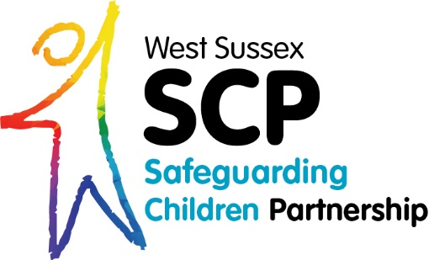

To find out more about ICON click on this link below:
https://www.westsussexscp.org.uk/professionals/working-with-families/keeping-babies-safe-useful-information-and-icon

