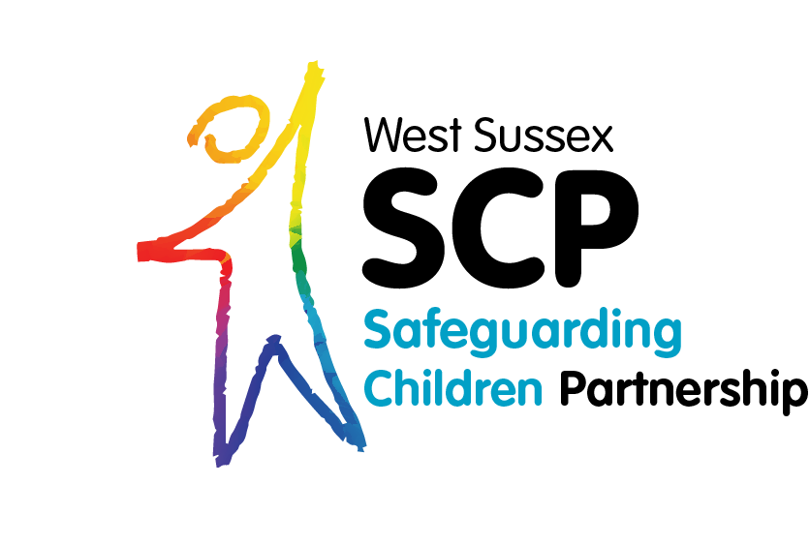
Private Fostering

What is Private Fostering?
When a child under the age of 16 (under 18 if disabled) is cared for by someone who is not their parent or a ‘close relative’. • A private arrangement made between a parent and a carer, lasting for 28 days or more.

How Do I Notify West Sussex Children’s Services?
Members of the public can phone 01403 229900 or email WSchildrensservices@WestSussex.gov.uk
Professionals should complete the Inter Agency Referral Form (IARF). Children’s Services will need to be sure that the child is safe, healthy and happy and can offer support to Private Foster Carers and parents where needed.

Who could be a Private Foster Carer?
- Extended family such as a cousin or great aunt.
- Friends of the family. • Parents of a friend of the child.
- Someone previously unknown to the child’s family who is willing to privately foster a child.

Children’s Services will need to be sure that the child is safe, healthy and happy and can offer support to Private Foster Carers and parents where needed.

If a Private Fostering arrangement is made, there is a legal obligation on carers and parents to notify the local authority.

For information on private fostering in West Sussex visit
the WSSCP website and the WSCC Private Fostering page

