Personal care

I get myself up in the morning using an alarm.

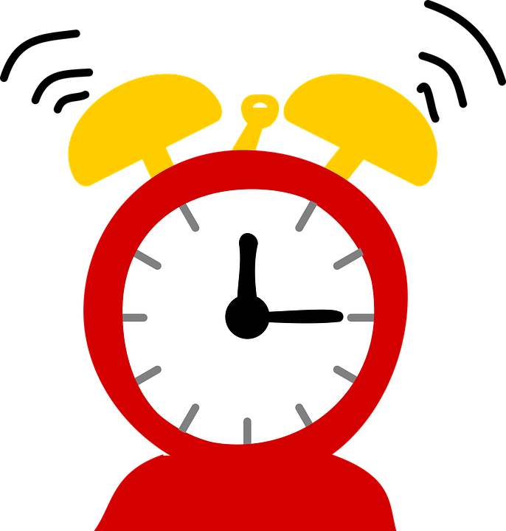

I need help with my personal hygiene.

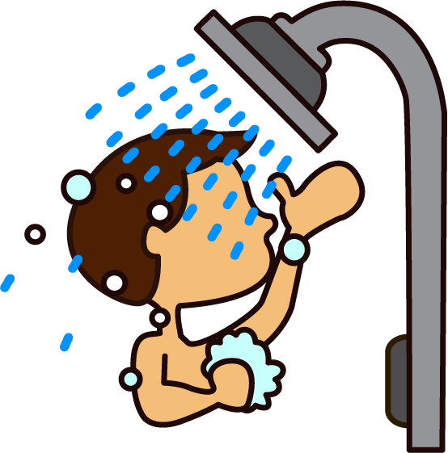

I have a bath or shower.

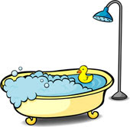

I brush my teeth.

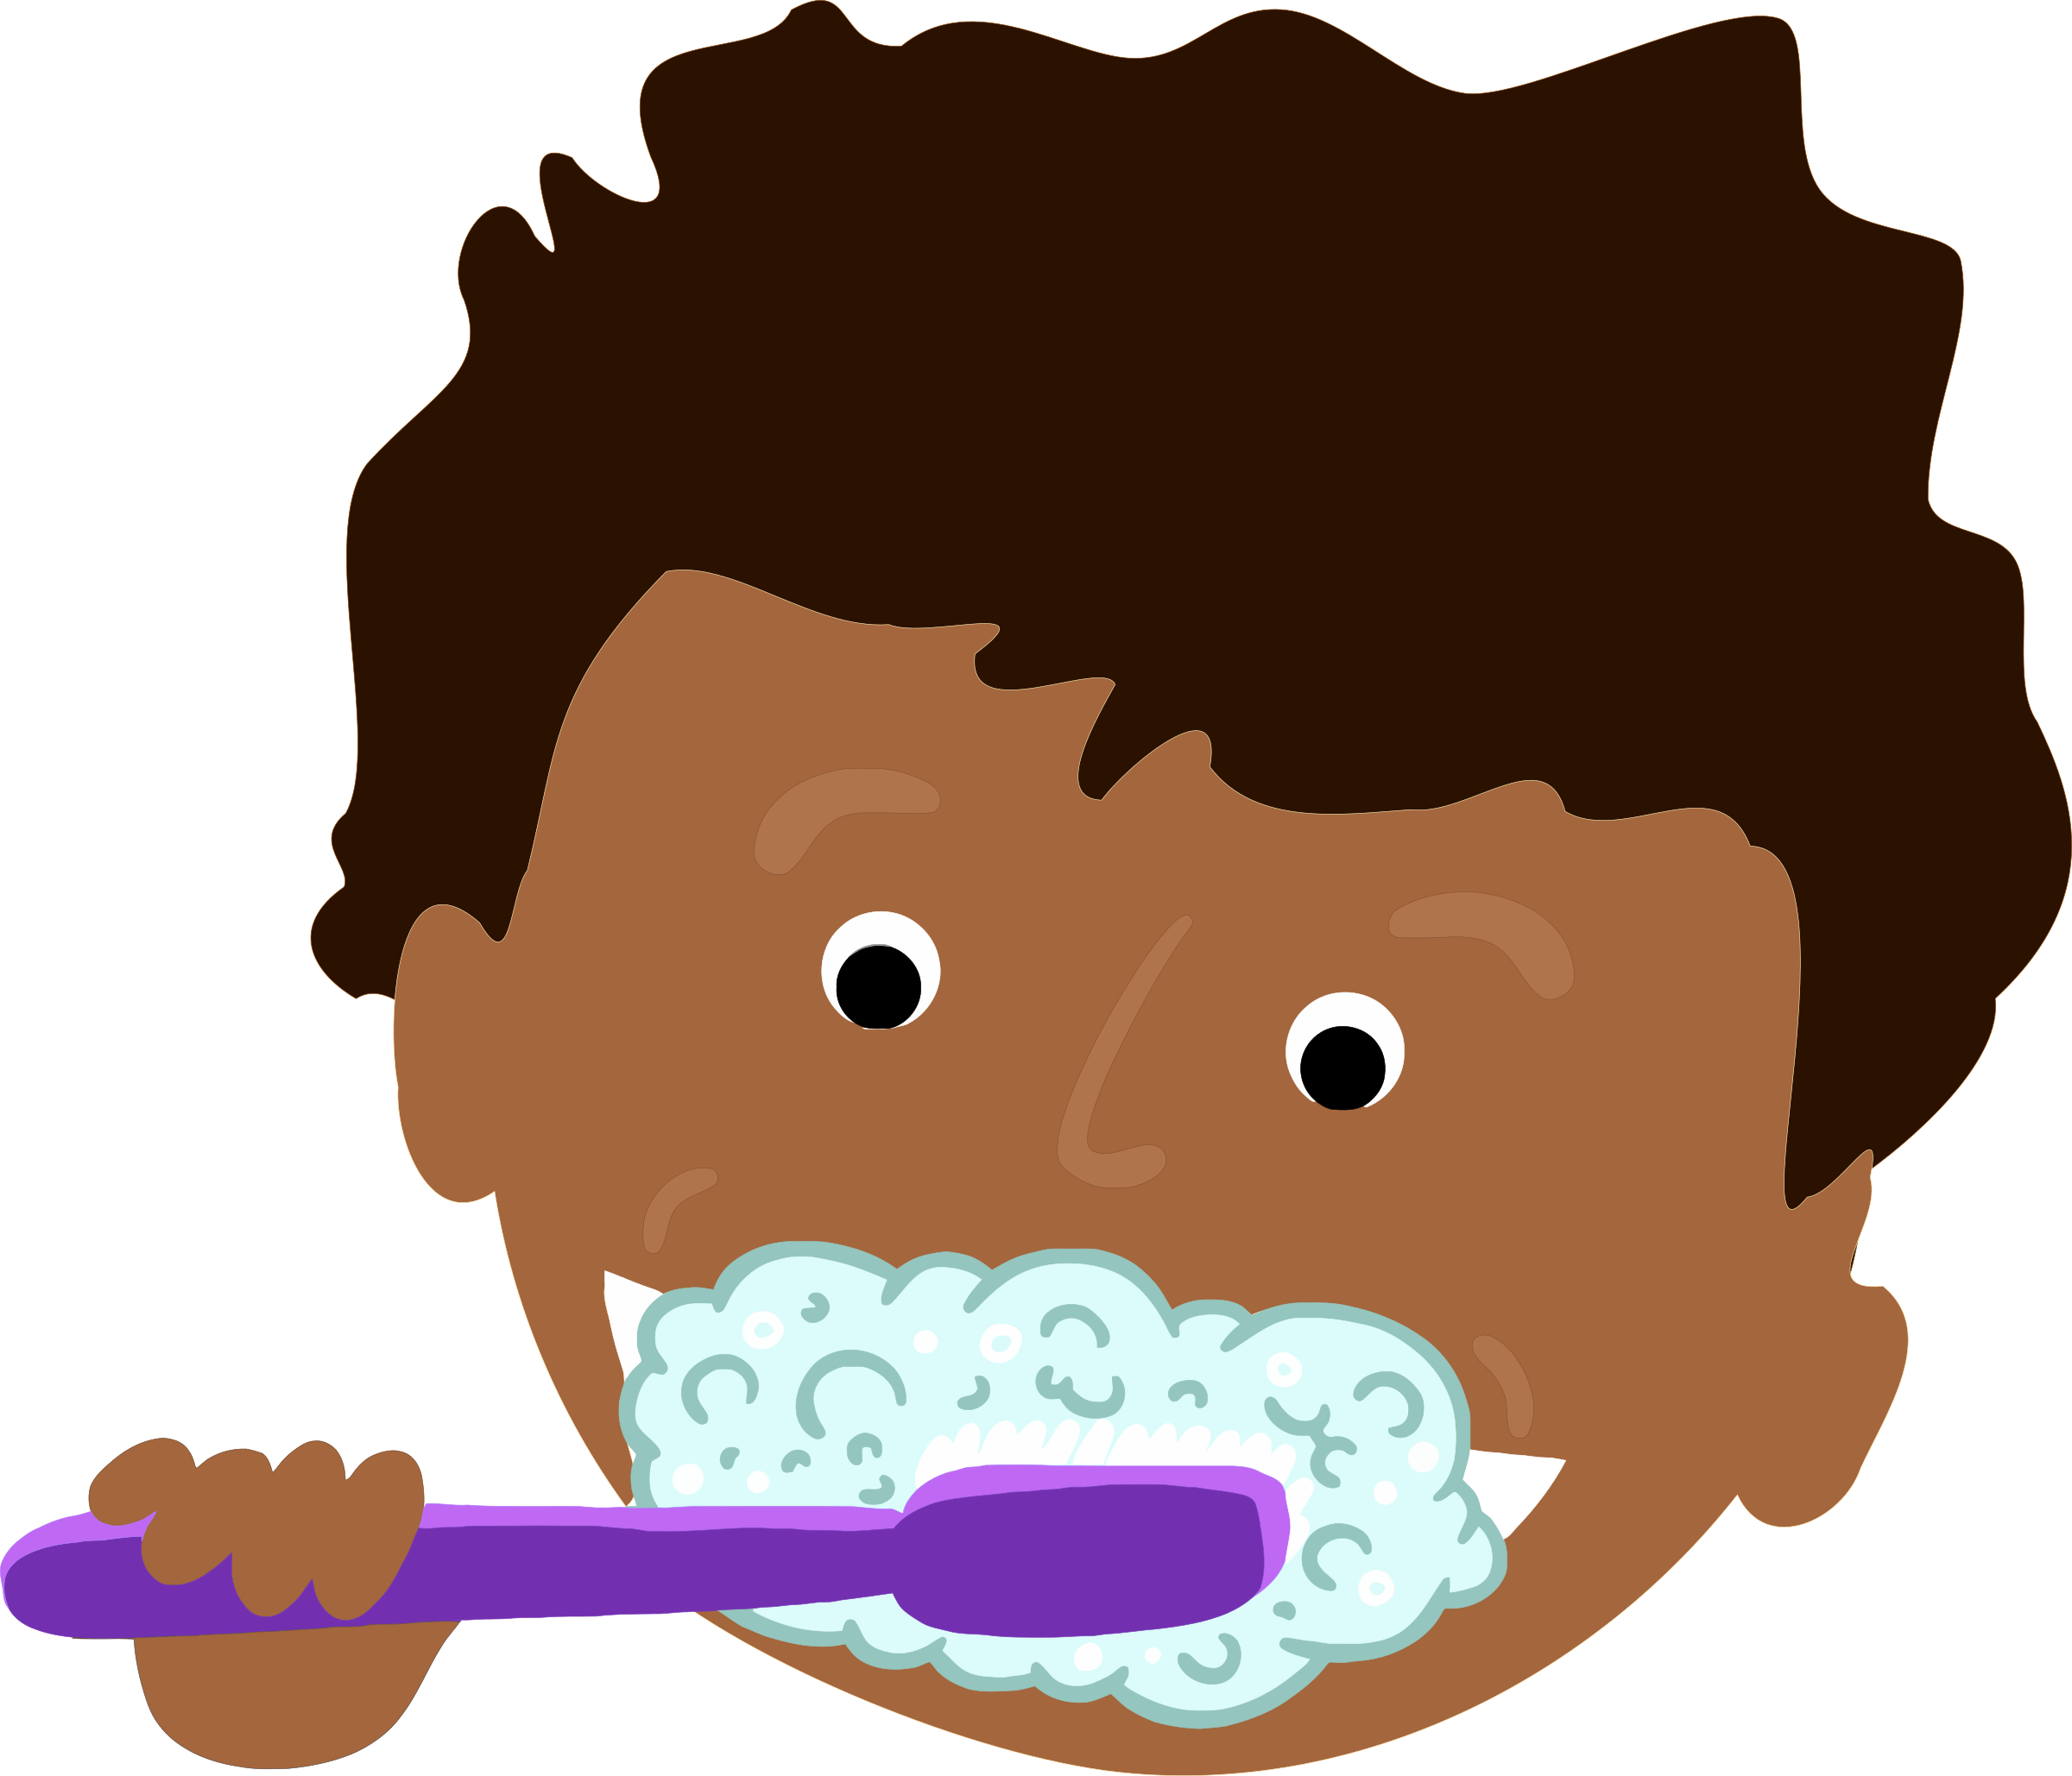

My clothes are clean.

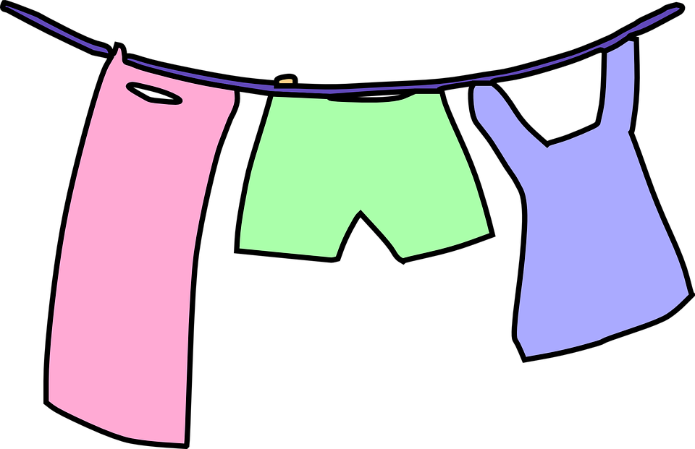

I have enough clothes and they fit me.

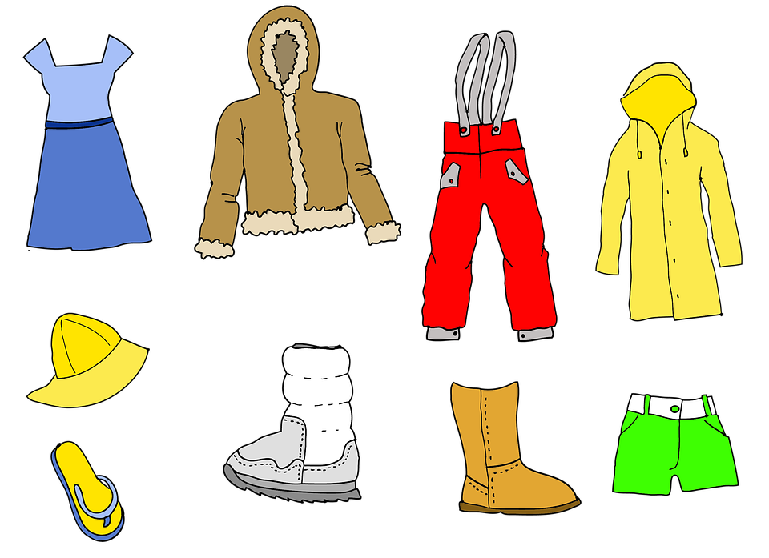

My bed is warm.

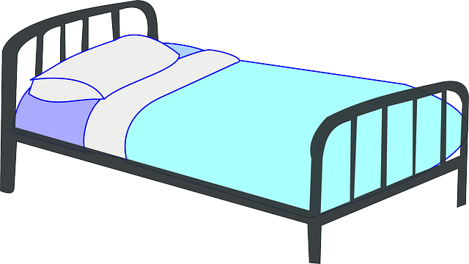

My bedding is washed and clean.

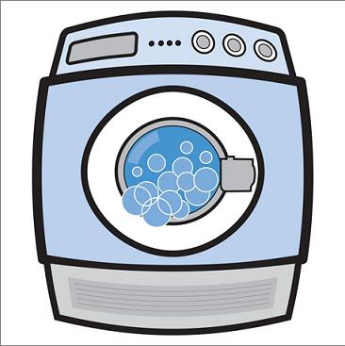

I like the clothes I wear and feel good in them.

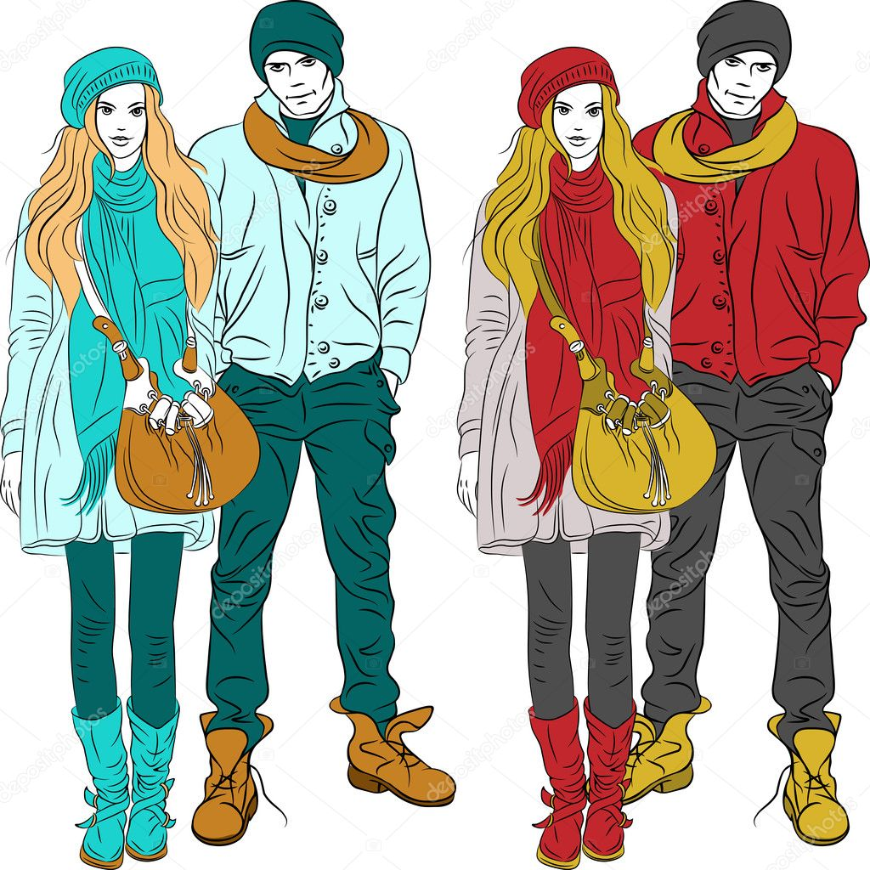

Mealtimes

I have a hot dinner at home.

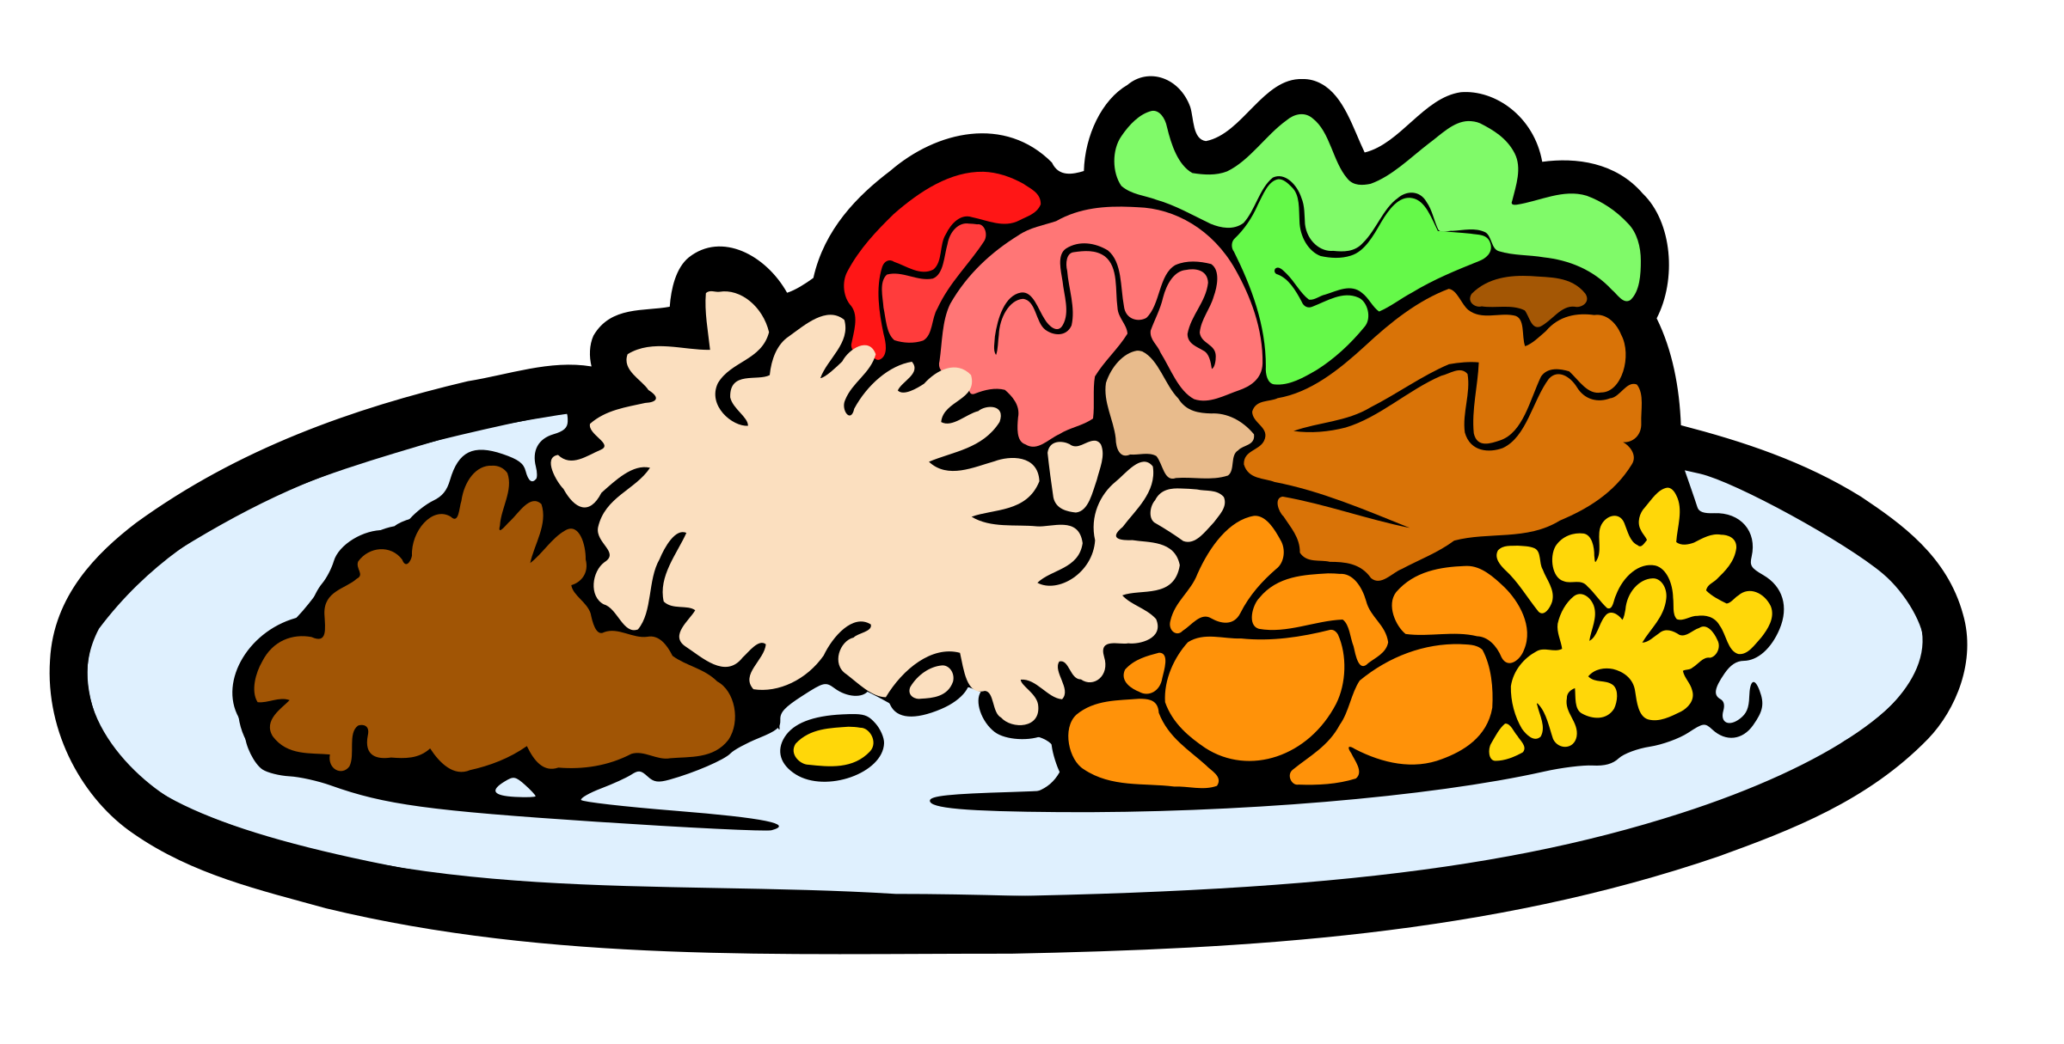

There is breakfast at home and I eat breakfast.

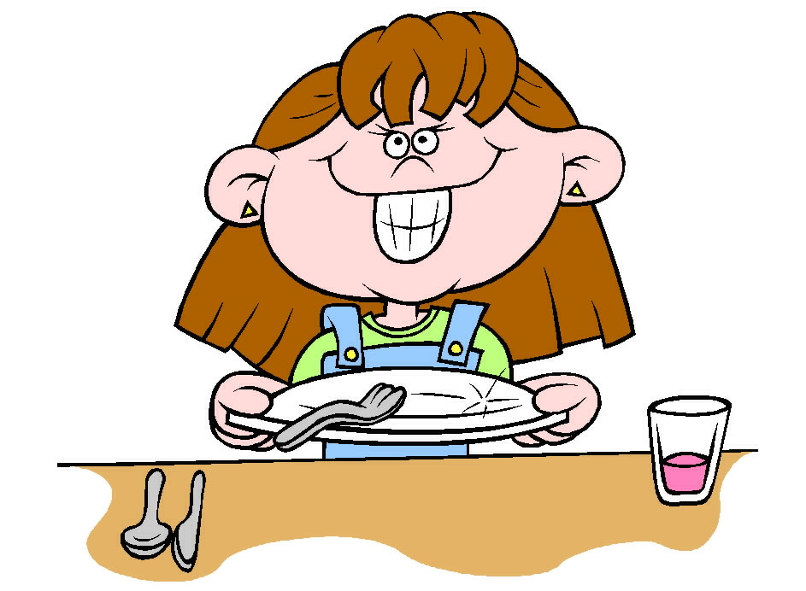

I have enough food on my plate so I am not hungry.



My mum/dad/carer makes me dinner.

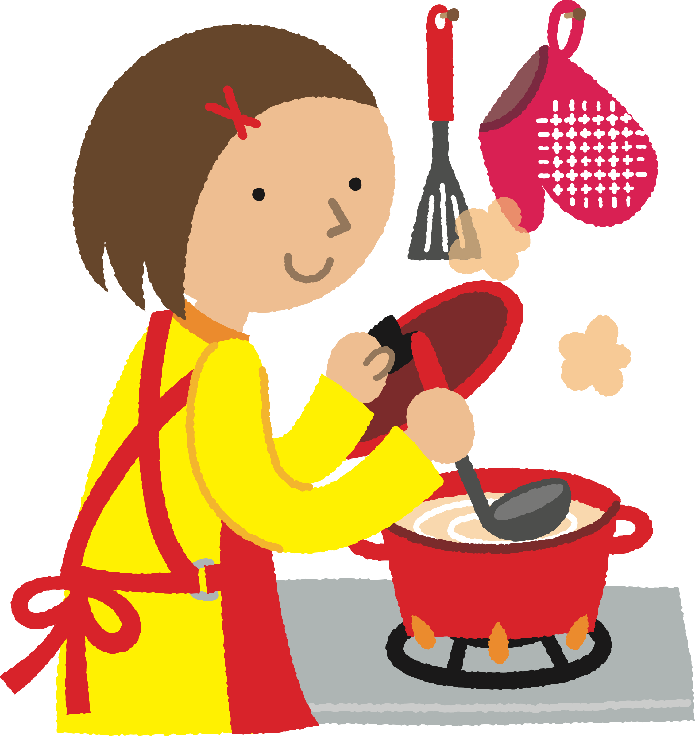

I eat dinner with my family.

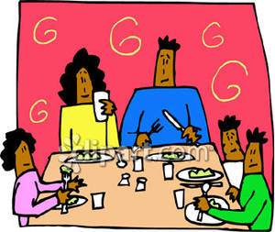

Love and affection

My siblings love me.



My mum/dad/carer loves me.



I see my grandparents, aunties, uncles, cousins and other people in my family.

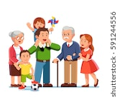

My mum/dad/carer hugs and kisses me and says nice things.

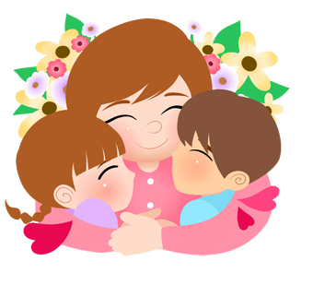

Supervision

People I don’t know come to my house.



I am at home on my own.

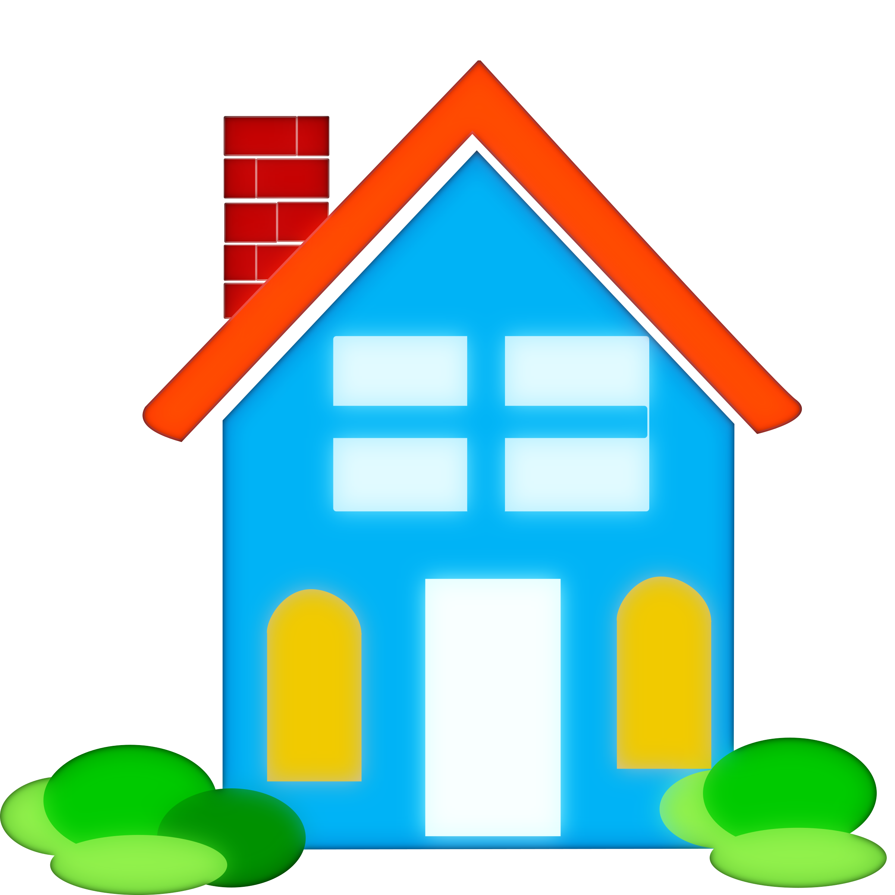

I have to look after my siblings.

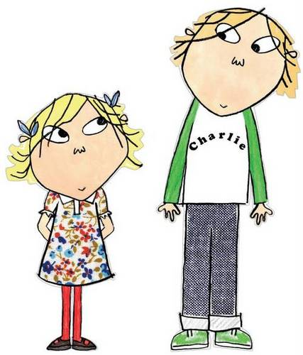

People other than my mum/dad/carer look after me.

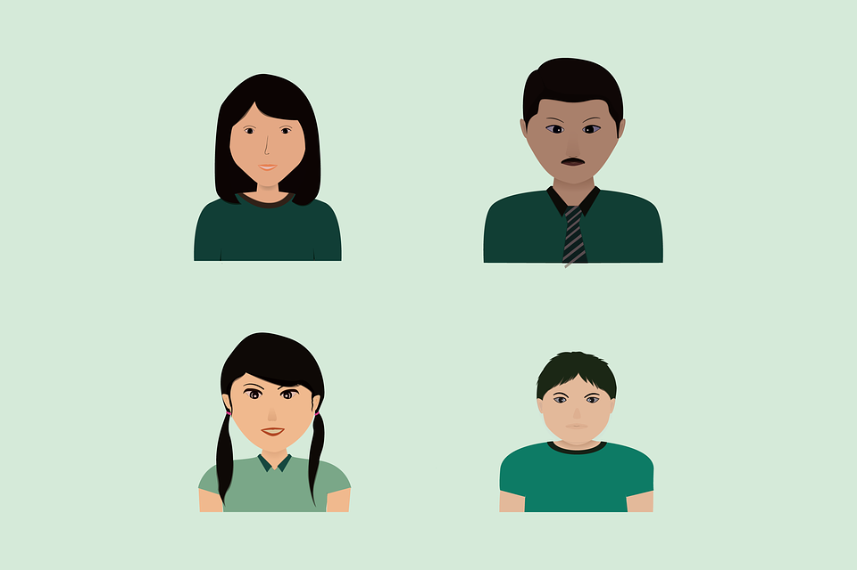

My mum/dad/carer checks what I am doing online.

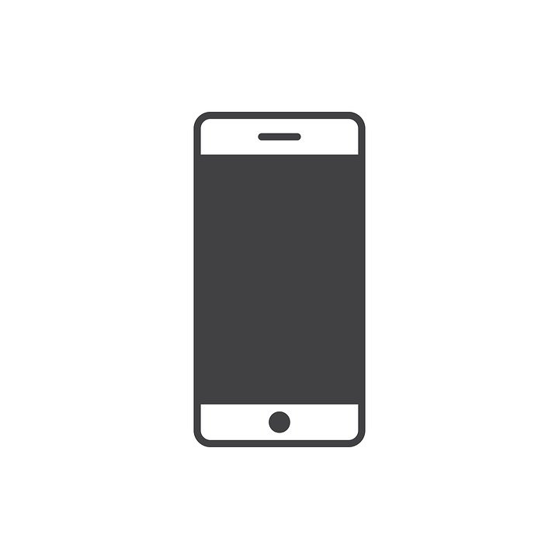

I have to be home by a certain time.

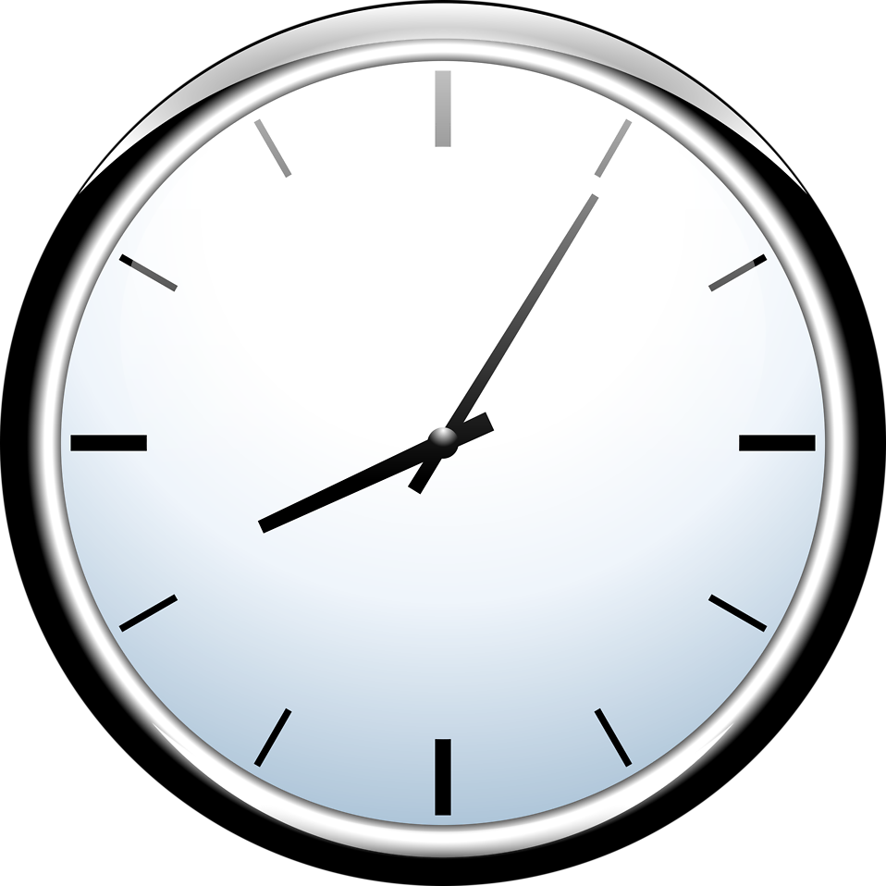

My mum/dad/carer gives me some independence.



My mum/dad/carer asks who I am going out with.

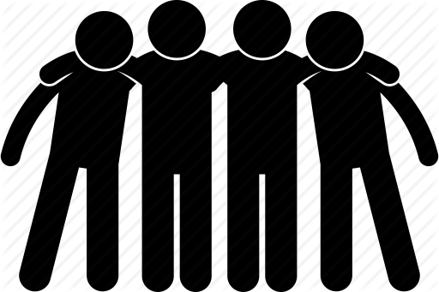

School

I am happy at school.

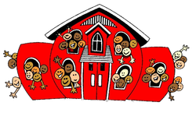

I am at school on time.

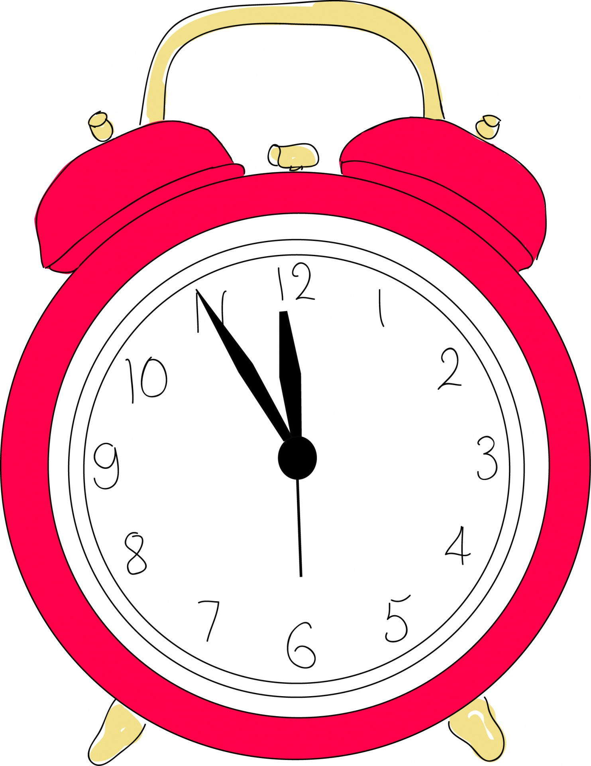

I have a packed lunch or school lunch.

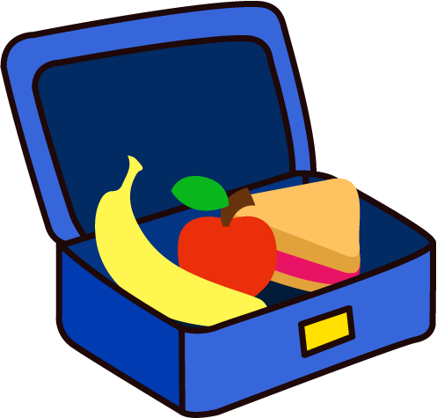

I have friends at school.

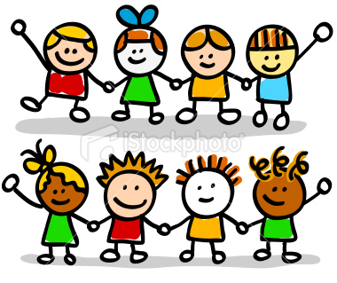

I am bullied at school.



I walk to school on my own.

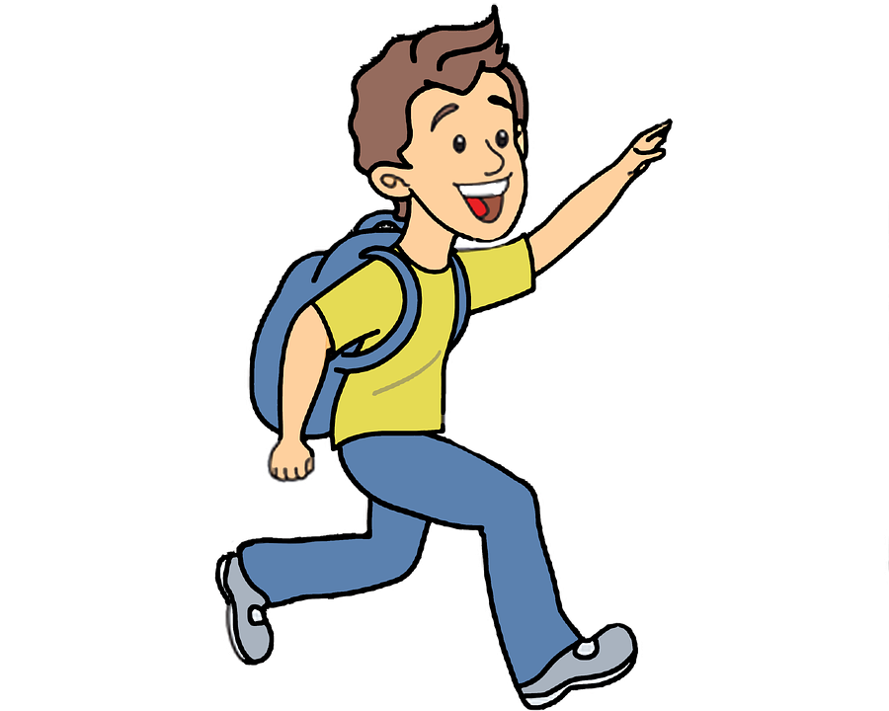

I take my siblings to school.

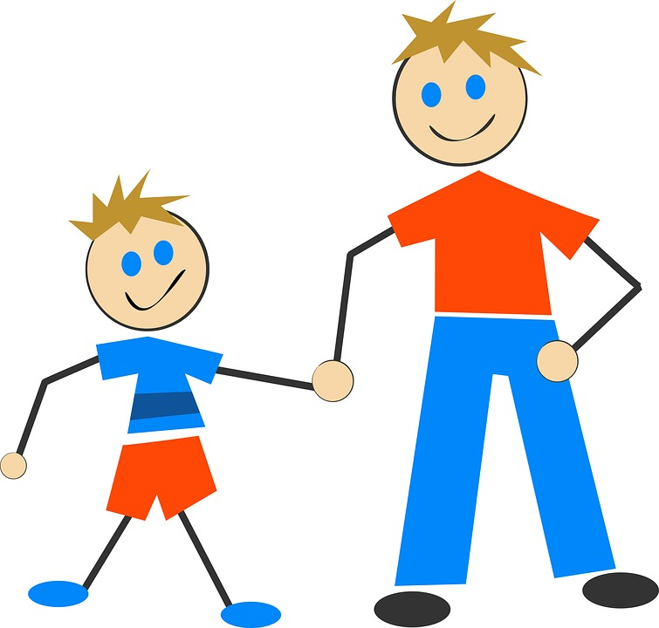

There is someone at school I can talk to.

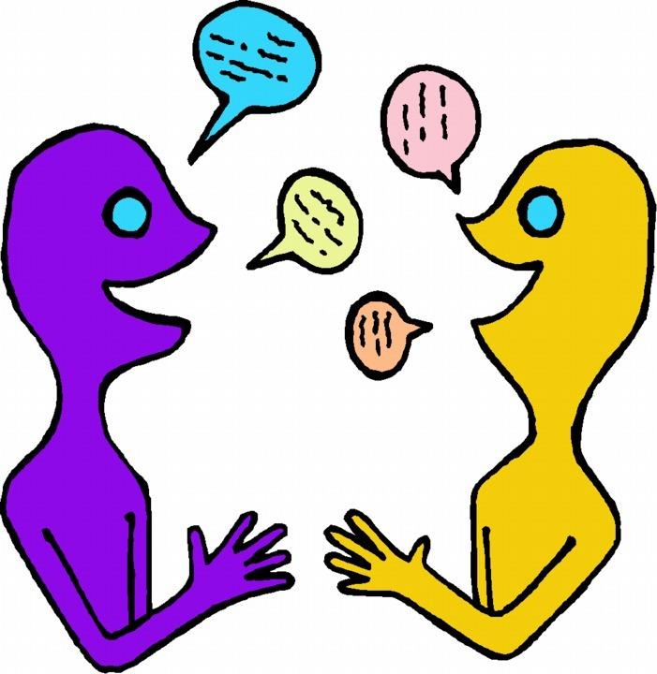

After school

My family are at home after school.



I watch TV or play on a games console.



I go to an after-school club or have a hobby.

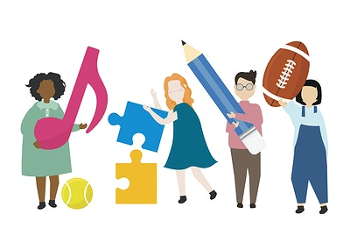

I have help with my homework if I need it.

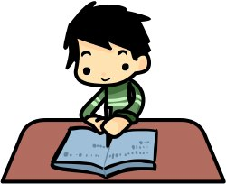

My mum/dad/carer asks me about my day and talks to me after school.

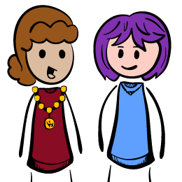

I have social media and/or watch YouTube.



Bedtime

I decide when it is my bedtime.

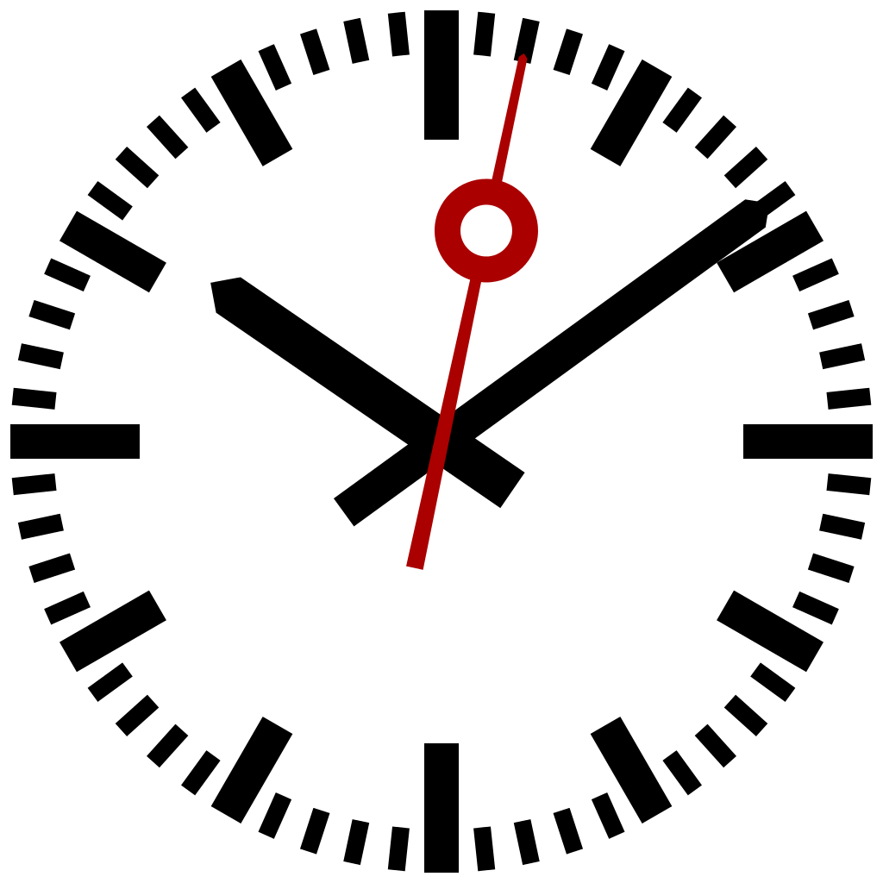

I get myself ready for bed.

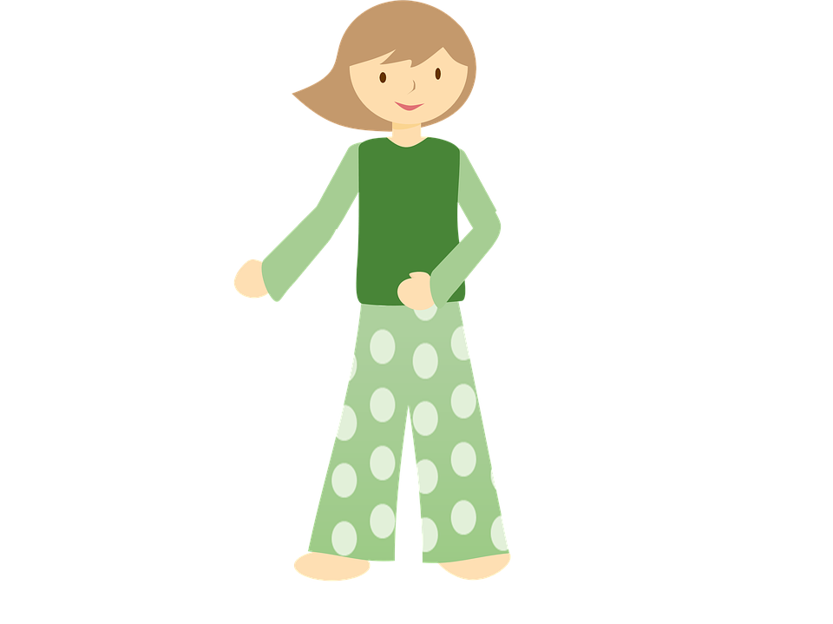

My mum/dad/carer says goodnight.



I go to bed the same time every night.

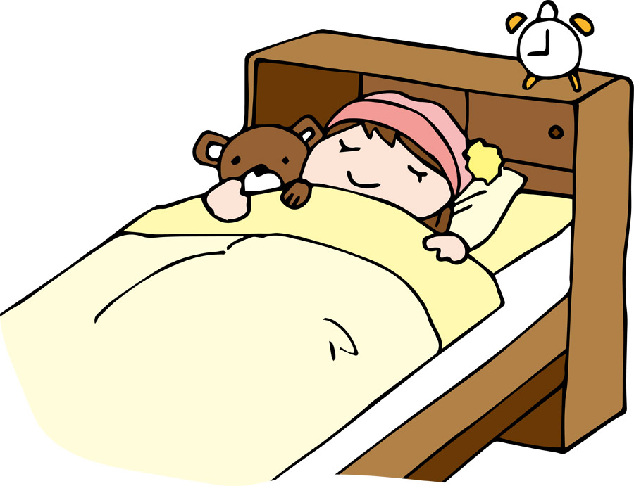

Medical

I see the doctor if I am worried about my health.

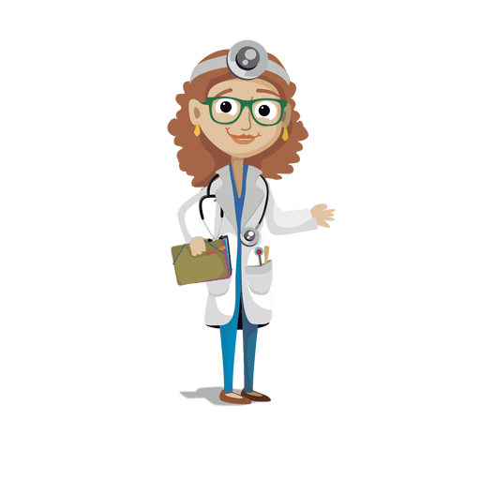

I go to the dentist.

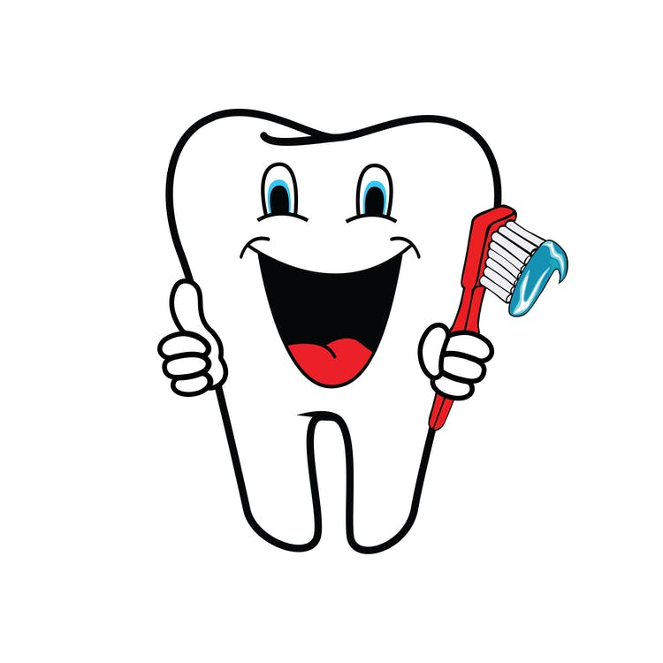

I drink alcohol and take drugs.

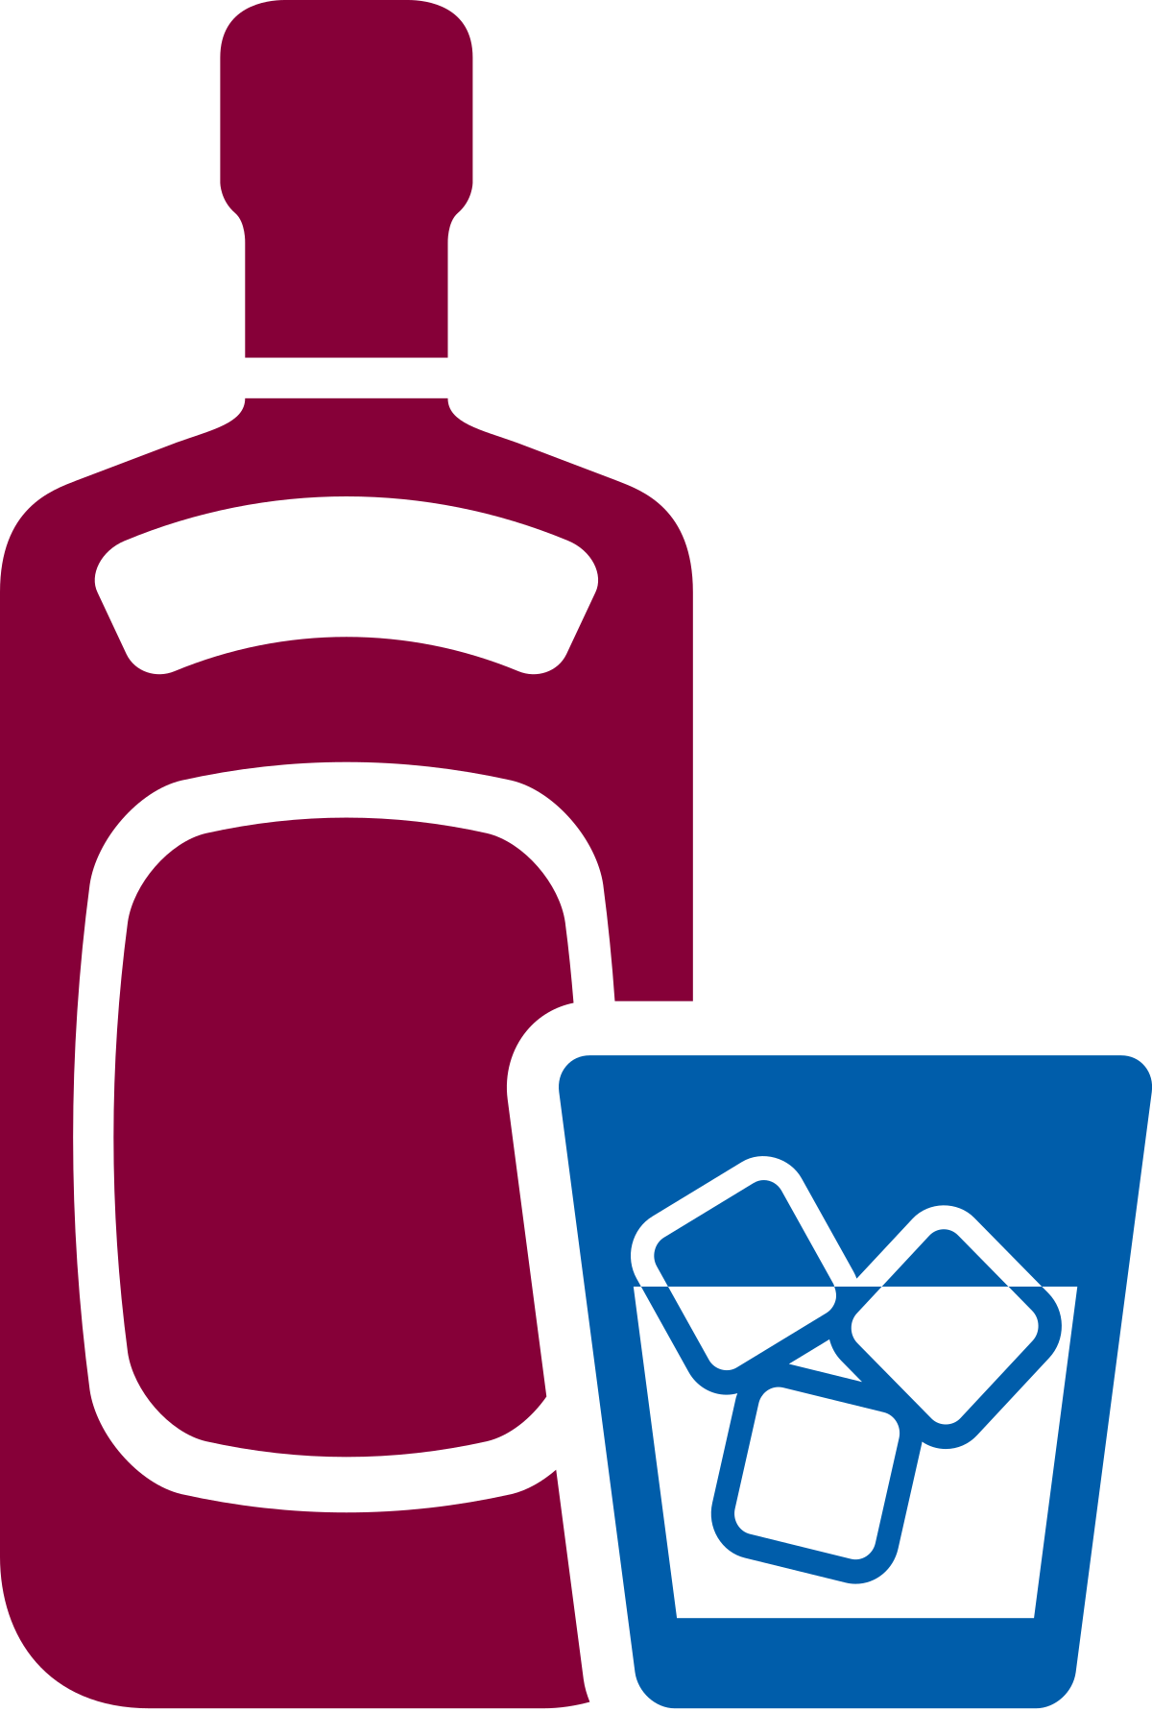

I have medicine if I am poorly.

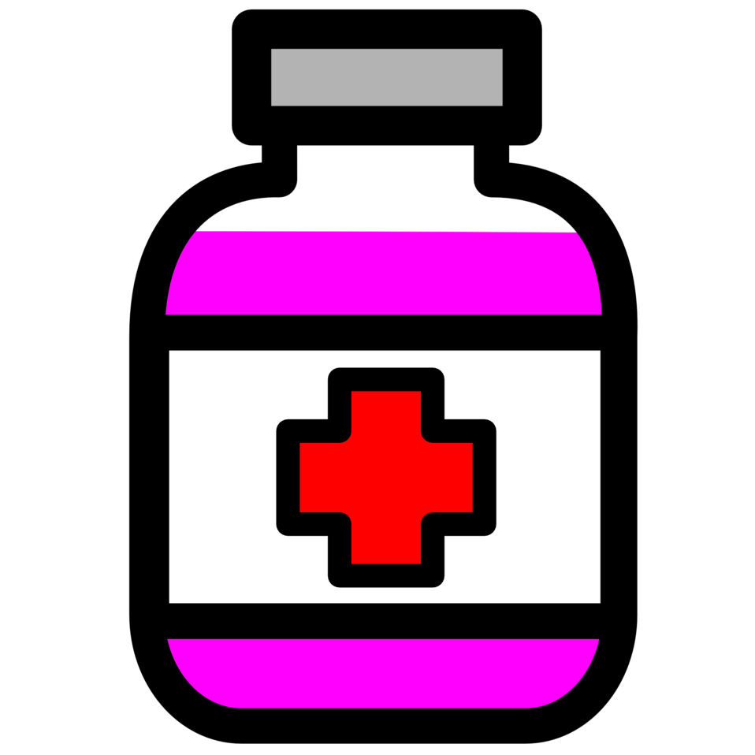

School holidays/weekends

I go out with my mum/dad/carers and siblings at weekends and in the holidays.

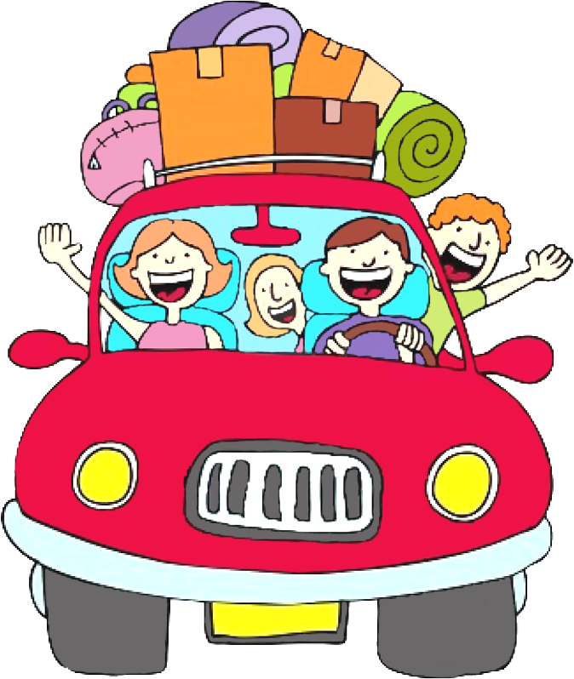

I go out with my friends.

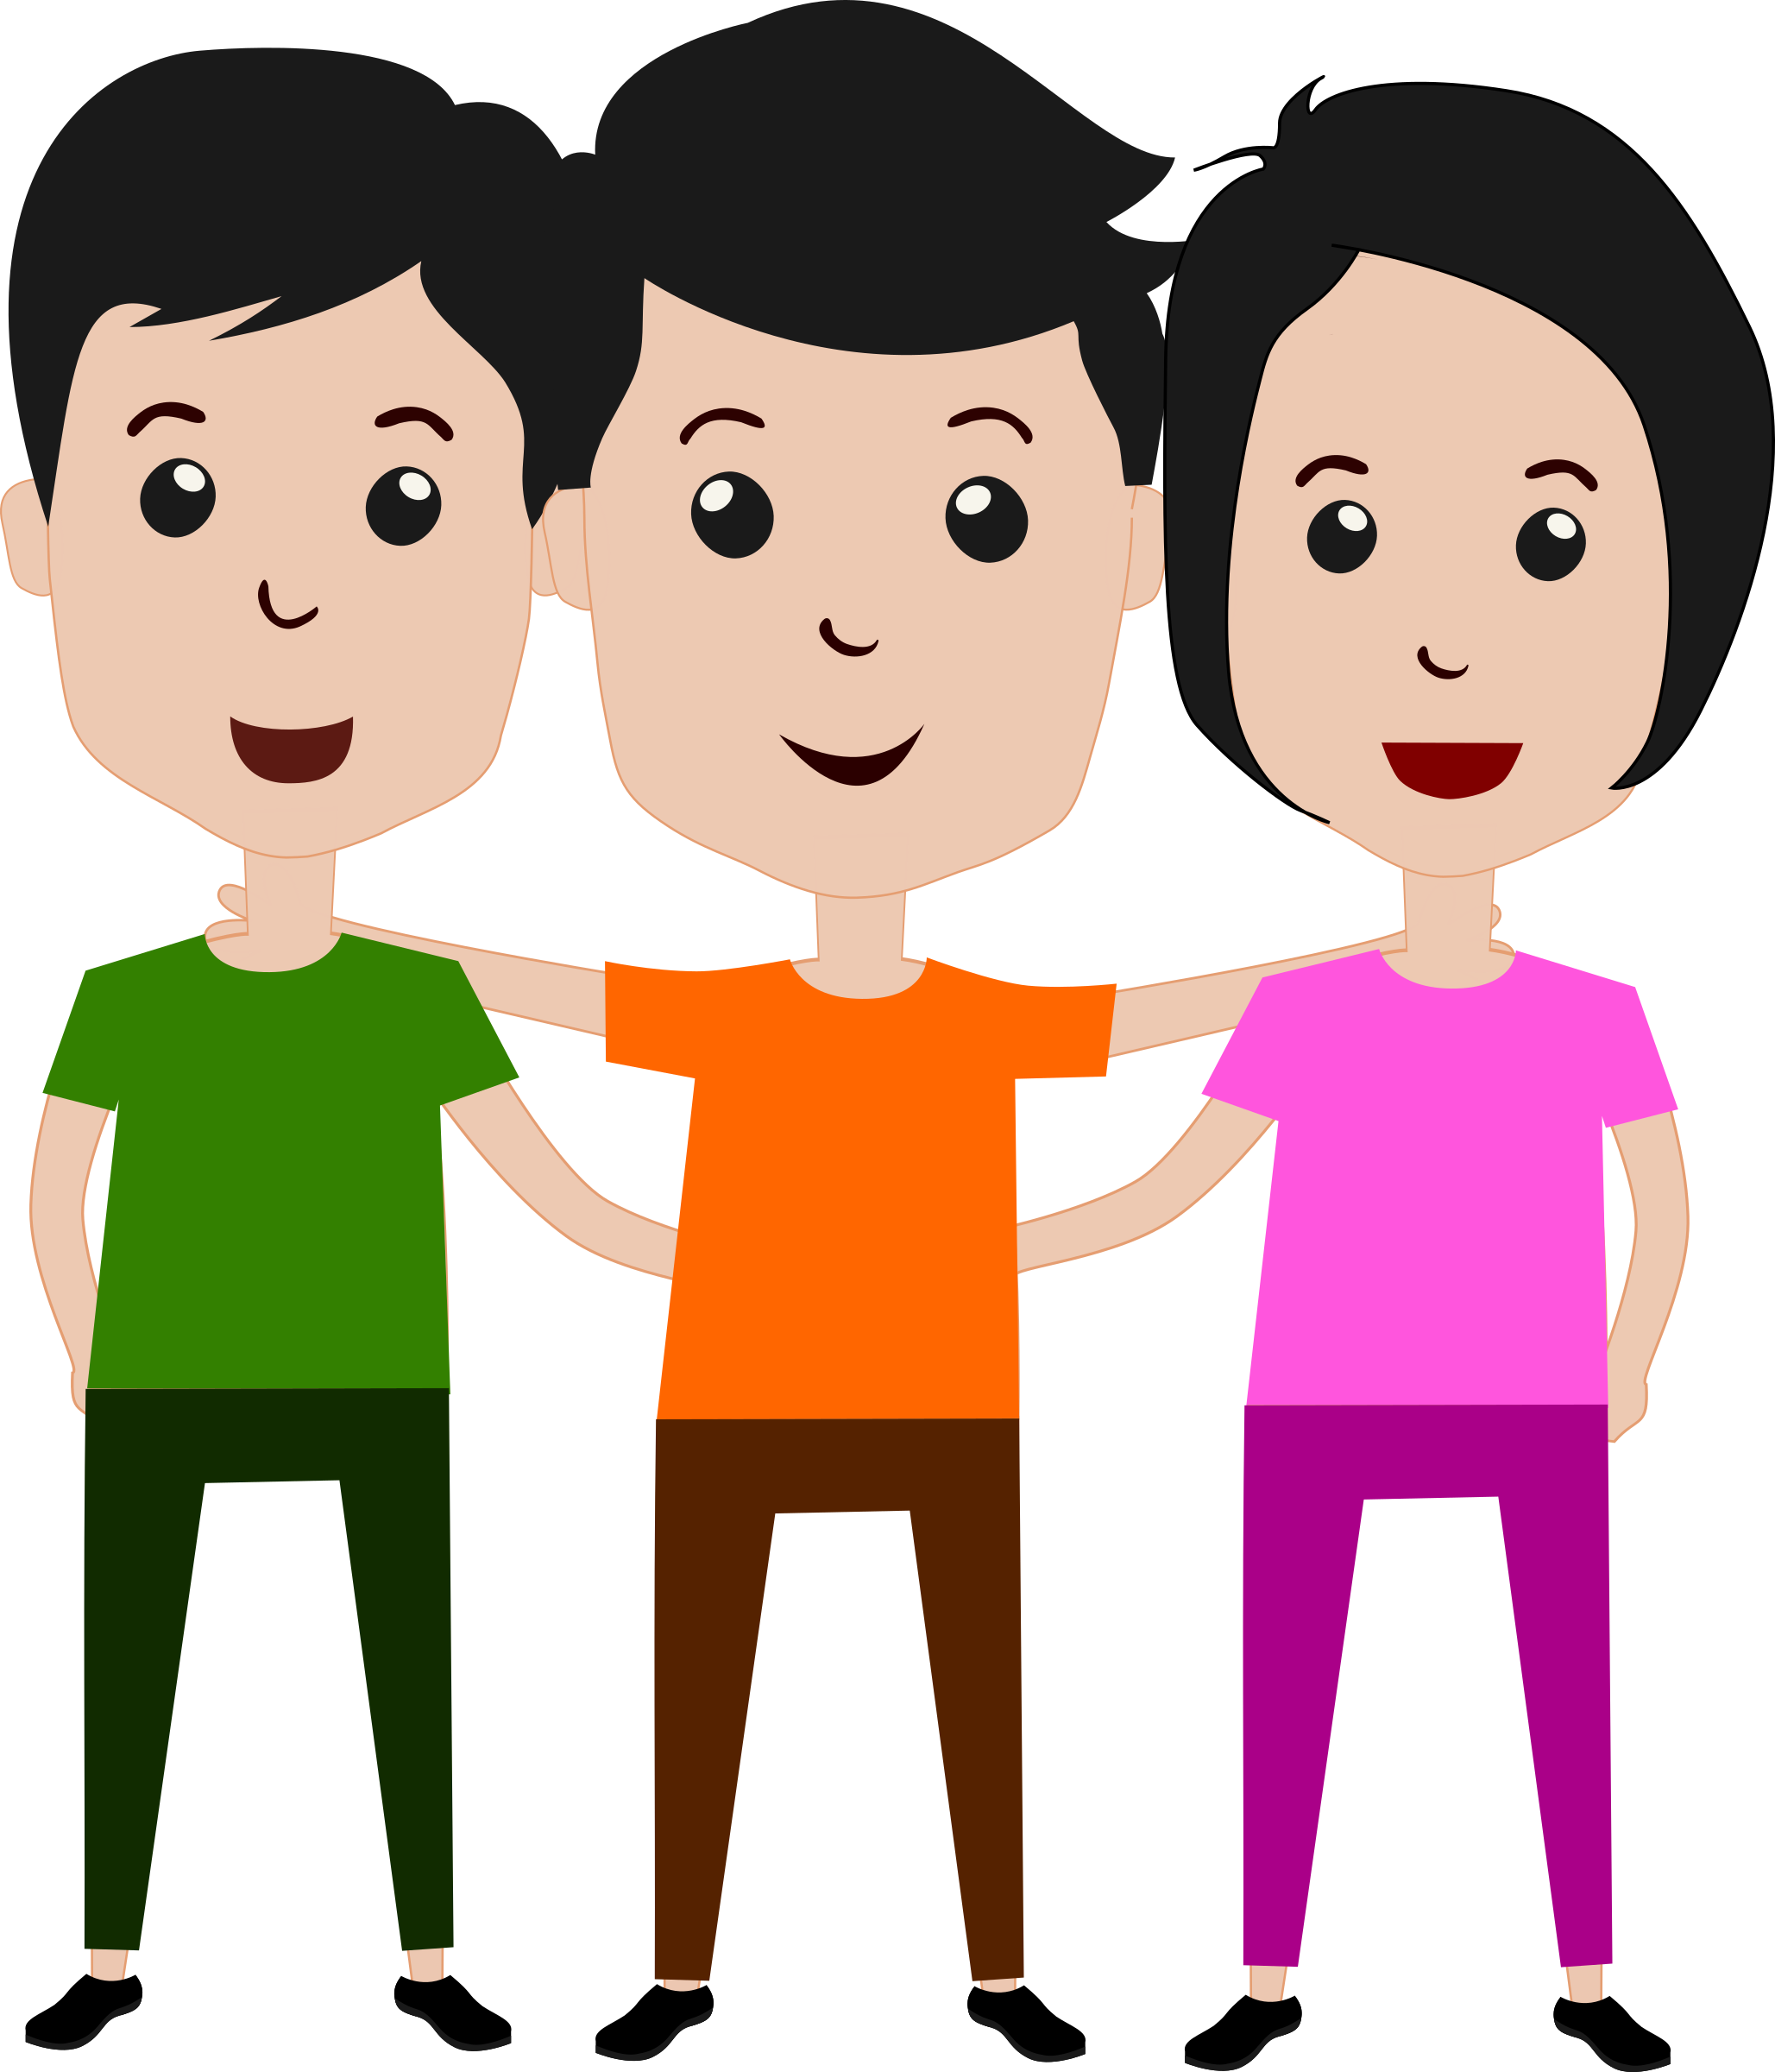

My mum/dad/carers work at the weekend in the holidays.

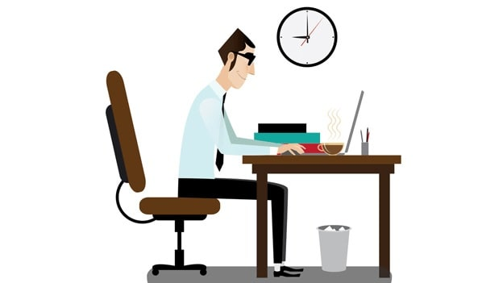

I have chores to do at home.

