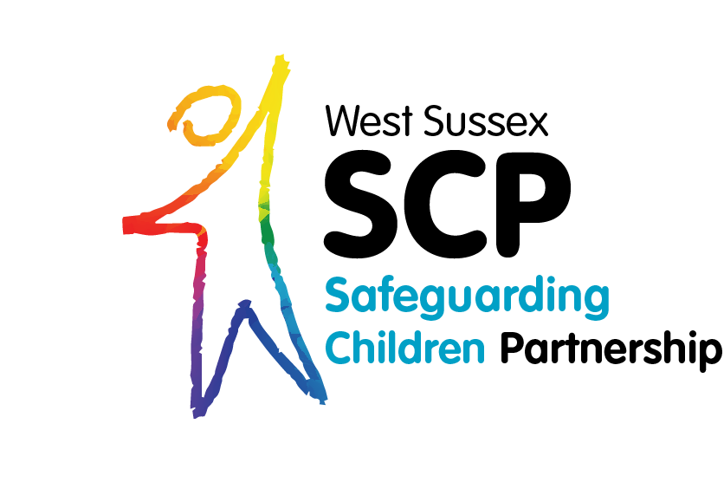
Planning a Conversation with a Young Person Who May be Pregnant

Briefing Sheet for Professionals
12th October 2020
Issue 0.1

Document Control
Version | Date | Reason | Who
0.1 | September 2020 | Initial Document | Marcella Mchugh

Approvals
Name | Title | Date of Approval

Stakeholders
Name | Title | Date of Review

Table of Contents

Document Control ii
Approvals ii
Stakeholders ii
1. Introduction 4
2. Planning a conversation with a young person 4
2.1 Rumour 4
2.2 Physical changes 5
3. Background information gathering 5
4. School nurse service 5
4.1 ChatHealth for young people 5
5. How many professionals should be present for the conversation 5
6. PAN Sussex child protection procedures 6
7. Gillick competency and Fraser guidelines 6
8. Abuse of exploitation 6
9. After the conversation with the young person 6
10. Referring to MASH 6
11. Record keeping 7
12. Sexual Health/Contraception 7
13. Consideration for having conversations with other young people 7

Introduction
Following a review, the West Sussex Safeguarding Children Partnership are sharing this briefing sheet in order to enable professionals to plan and hold a conversation with a young person where there is an indication the young person may be pregnant.

The information that the young person may be pregnant may have come to the attention of the professional either by rumour or by observation of physical or emotional changes in the young person.

Any staff member being made aware of possible significant healthcare needs of children (such as possible pregnancy) are always encouraged to approach members of the healthcare team for advice, this may be the school nurse or sexual health advisor for example. This briefing sheet identifies where professionals can obtain further advice.

Planning a conversation with a young person
Before having a conversation with the young person, due regard will be given to whether the parent or carer/s should be invited to be present for this conversation. Each case must be considered on an individual basis, identifying whether there are any risks to the young person in sharing the concerns with the parent. All factors will be considered including the age and understanding of the young person and whether the young person themselves has already spoken to their parents.

If staff consider it would not be appropriate for the parent / carer to be invited to attend the conversation, and / or risks to young person are identified the staff member MUST seek supervision from their safeguarding lead to consider next steps BEFORE any conversation with the young person takes place, including whether staff should encourage the young person to share the circumstances with their parents or carer/s.

Rumour
Responding to rumours with young people:-

It is not uncommon when working with young people to hear rumours. To ensure professionals are responding safely, the person hearing the rumour must consider the following:
- Does the rumour relate to an issue that may put the young person or another at risk if true?
- Is there any other information or observation you have made that could indicate that the rumour is true? For example, you know the young person is sexually active.
- Is the young person from a vulnerable group?
- Do you have any other concerns for the young person?

If any of the points relate to the young person, the worker must seek oversight from a manager. The worker and manager will consider the nature and source of the rumour, identify any risk factors, review the young person’s record and may seek further information from other workers who know the young person well. If appropriate the worker will speak to the young person concerned, someone from their network of support or their parent / carer.

Physical changes
As with all conversations with young people, professionals will plan to hold the conversation in the right location and support the young person both during and after the conversation. Professionals must consider that any conversations they have with a young person around changes in their physical appearance are of a sensitive nature and should be particularly mindful of this during the discussion.

Background information gathering
Before any decision is made to see the young person, professionals will review what information is already known. For example, are any other agencies currently involved with the young person or family and whether there are any known additional vulnerabilities. This is not an exhaustive list but for example, Special Educational Needs or Disability, being a Young Carer or Child Looked After, or known to be at risk of exploitation.

School nurse service
Professionals can seek medical advice and opinion from specialist services such as sexual health and school health. All schools in West Sussex have an allocated school nurse team and all children resident in West Sussex can be referred to the school health team. If schools, other health professionals, Early Help, social care etc wish to refer into school nurse service, a referral form into the School Nurse service must be completed.

If a professional wishes to submit a referral form or is unsure whether to refer to the school nursing team, or would like some advice, they should contact the Healthy Child Programme Team. More information about the healthy child programme can be found on the Healthy Child Programme Team
website.

ChatHealth for young people
Young people can also have direct access to a school nurse by using the ChatHealth facility. This can be used by any young person by texting 07480 635424. More information about ChatHealth can be on the ChatHealth website.

How many professionals should be present for the conversation
If a decision is made to have a conversation with the young person consideration will be given to whether having more than one professional to meet with the young person is appropriate; this may be beneficial in order to allow observation of the interaction. The young person may be asked if they would like additional support from a trusted adult, or whether an advocate is required. Professionals must balance the presence of two professionals against the potential of overwhelming the young person and decisions to have more than one professional present for any conversation will be made on a case by case basis.

PAN Sussex child protection procedures
All staff must have an awareness and understanding of Pan Sussex Child Protection and Safeguarding Procedures, more information can be found on the procedures website, in general and in particular 8.13 Concealed Pregnancy and 8.40 Sexually Active Children.

Gillick competency and Fraser guidelines
When making decisions staff should also be aware of the principles of Gillick Competency and Fraser Guidelines website. Staff can seek further advice where necessary from a school nurse / other health care provider.

Abuse of exploitation
When discussing a possible pregnancy with the young person staff must consider whether there are concerns that any sexual activity is abusive or exploitative. Information for professionals around abuse / exploitation can be found on the West Sussex Safeguarding Children Partnership website.

After the conversation with the young person
It is possible that a young person may not know they are pregnant, or they may have taken a pregnancy test that concluded to be negative. Professionals must be fully aware that even if a pregnancy test is negative but other signs are indicating a pregnancy the staff member will be mindful that a pregnancy is still possible. In such cases professionals MUST seek further advice from a health care professional as soon as possible.

It is important that all professionals are mindful that a young person may absolutely believe they are not pregnant when in reality they are pregnant. If professionals consider this may be the case, they MUST seek further advice, either by contacting the Healthy Child Programme, School Nurse, Early Help or where necessary MASH, depending on the circumstances.

If after the conversation the young person maintains they are not pregnant, and there are no obvious signs that they are, good practice dictates the information will be shared with any other professionals already working with the young person and with school nursing. Please see the information sharing guidelines on the safeguarding partnership website.

Referring to MASH
Immediately after the conversation, professionals MUST critically reflect on all the information they have and MUST consider whether any safeguarding referrals are appropriate at this point.

if the staff member considers a referral needs to be made to MASH the young person should be informed that this is taking place. Professionals should also inform parents / carers that a referral is being made to MASH unless there are concerns that by informing the parents / carers before referring to MASH could escalate the risk to a child or impede a police investigation.

Professionals can contact MASH if they unsure whether to refer concerns. Further information about contacting MASH can be found on the MASH website

Record keeping
Any conversations held with a young person where it is believed the young person may be pregnant must be recorded on the young person record by the worker who spoke to the young person.

Where the decision is taken not to have a conversation with the young person, that too must be recorded and the reasons why no conversation was to take place clearly recorded.

Sexual Health/Contraception
If, during the conversation, the young person shares they are not pregnant but are sexually active then if the child is under 13 then the matter must be referred to MASH immediately.

If the child is aged between 13 – 17, consideration will be given to the age of the young people involved to ensure there is no power dynamic, coercion or manipulation in operation. If there are any doubts as to whether the young person is being coerced or a victim of exploitation MASH MUST be contacted for advice.

If there is no information to indicate contact is required with MASH at that time, open a conversation with the young person to ascertain the young person (and their sexual partner) have considered:
- The use of reliable contraception, and the young person is aware of the choices available
- The young person has received contraception and sexual health awareness advice including the use of condoms with a discussion and demonstration from an appropriately trained professional
- The young person is aware of how and where to obtain emergency contraception
- The young person has an awareness of STI’s and how to obtain testing

If through the conversation it is clear that the young person may not have considered any of the above strongly encourage the young person to attend their local sexual health services either via via Sexual Health West Sussex website or via their GP.

Consideration for having conversations with other young people
Staff are also reminded that, after a conversation with a young person who may be pregnant, they will consider others who else may need support, for example sexual health guidance or other support for other young people. It is anticipated that schools and colleges will provide general advice and support to their students via the relationship and sex education curriculum however staff should decide to hold a conversation with a young person regarding sexual health, advice and support on a case by case basis.

