West Sussex Safeguarding Children Partnership Quality Assurance and Scrutiny Framework

June 2020
Issue 0.1
Author:- Marcella McHugh
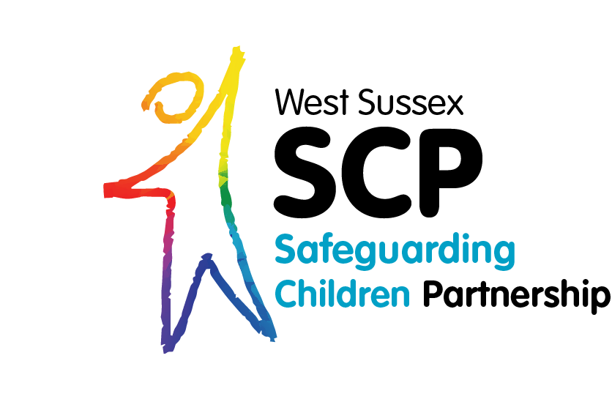

Table of Contents

1. Purpose 3
2. National and Local Context 3
2.1 The Local Context 3
3. Principles 3
4. Approach to Quality Assurance and Scrutiny 4
4.1 Audits 5
4.2 Section 11 Audits 5
4.3 Line of Sight of Practice/Practice Observations 5
4.4 Learning from local and national serious case reviews and learning reviews 5
4.5 Workforce development and learning 6
4.6 Feedback 6
4.7 Performance Management and Data 6
4.8 Learning from the best 6
5. Independent Scrutiny 6
5.1 The role of independent scrutiny 6
5.2 Approach to scrutiny 7
5.3 The scrutiny learning process 8
5.4 Planning 8
5.5 Practice scrutiny learning events 9
5.6 Outputs from practice scrutiny learning events 9
5.7 Overall effectiveness of the partnership 10
6. Governance and accountability 11
7. Conclusion 12
8. Annex A – Approvals 12

Purpose
West Sussex Safeguarding Children Partnership is committed to having an assured safeguarding partnership which collectively engages with children and families enabling them to thrive. This Quality Assurance and Scrutiny Framework will support the partnership vision, by ensuring that children, families and practitioners are fully engaged in the processes that improves the quality of safeguarding practice.

Measuring the impact of our work at all levels across the partnership is crucial to improving safeguarding outcomes for children. This framework identifies the WSSCP quality improvement methods that the partnership will use to drive continuous improvement and includes the principles and processes for quality assurance and scrutiny. It also outlines the governance and accountability arrangements for the Framework.

National and Local Context
The Wood Review (2016) identified the need for independent scrutiny arrangements to assess outcomes of multi-agency practice, including how intervention happens if performance falters. The Children and Social Work Act 2017 reframed the approach to local safeguarding by removing the statutory requirement for local authority areas to have a Local Safeguarding Children Board and placing a duty on three lead partners: Police, Clinical Commissioning Groups and the local authority to agree local arrangements to work together to safeguard children. West Sussex Safeguarding Children Partnership published its arrangements on 25th June 2019.

Working Together to Safeguard Children (2018) establishes the guidance for partnership arrangements. The guidance is clear that ‘the decision on how best to implement a robust system of independent scrutiny is to be made locally.’ It does however specify that ‘safeguarding partners should ensure that the scrutiny is objective, acts as a constructive critical friend and promotes reflection to drive continuous improvement’.

The Local Context
West Sussex Children’s social care services were judged inadequate by Ofsted in May 2019. In addition to the external monitoring provided by Ofsted, the DfE and the commissioner, it is incumbent on the partnership to ensure that core safeguarding practice is robust to ensure that children in West Sussex are safeguarded.

Principles
The Partnership is committed to driving continuous improvement, to ensure better outcomes and experiences for our children, young people and families. The principles identified below will provide the frame of reference for the quality assurance activities and the scrutiny process outlined in this framework.
- Child Centred Practice. Children and young people are competent individuals. A child centred approach requires professionals to ensure they are working with children and young people rather than working alongside them. The partnership will ensure that children and young people have opportunities to participate and collaborate in the work of the Partnership and that the voice of children is embedded in multi-agency practice.

- High support high challenge. Systems that develop and promote a culture of high support and high challenge will enable working environments where growth and learning is accelerated.

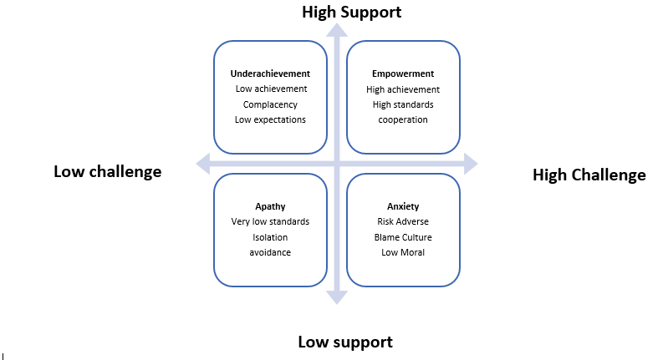

- Promoting Practice leadership. Leadership is distributed across the partnership and inherent in effective leadership is the desire and willingness to learn and develop both individually and organisationally. Involving practitioners in the continuous learning process of quality assurance and scrutiny in a supportive and challenging way, will build practice leadership capacity across the partnership.

- Restorative approach. An important shift in the quality assurance and scrutiny process will be to adopt the approach of ‘working with’ rather than ‘doing to’. This will not only apply to practitioners but also to children and families and wider stakeholders, who will all be involved in the quality assurance process and scrutiny events. This will lead to strengthening relationships not only across the partnership but also with children and families.

- Promoting a culture of continuous learning. The reflective and analytical approach to quality assurance and scrutiny underpinning this framework will create the environment for learning, recognising the way systems influence each other and the benefits of working together rather than in individual agencies. Shared learning enables systems to solve problems more efficiently.

Approach to Quality Assurance and Scrutiny
The partnership has a range of quality assurance mechanisms to enable ongoing analysis of practice and performance. Some of these processes are well embedded for example S.11 audits, whilst others like Child Safeguarding Practice Reviews and Local Learning Reviews are responsive to specific incidents. However, it is recognised that some of these elements will be new to the partnership such as independent scrutiny.
The quality assurance and scrutiny processes need to be robust and include learning from research, local intelligence leads, benchmarking with statistical neighbours and national best practice to ensure evidence informed actions and learning.

Audits
Partnership audits include single and multi-agency audits. The audits may be thematic or focus on a specific area of safeguarding. The Partnership previously focussed on information recorded on case files. More recent work has directly involved hearing the voice of children and their families and practitioners. However, it is critical this more collaborative and reflective element is built in as a standard element of this work. This will lead to enhanced real time learning for practitioners, richer learning for the Partnership and more focussed recommendations for change.

Section 11 Audits
Section 11 audits places a statutory duty on key organisations, to ensure that in discharging their functions, they have regard to the need to safeguard and promote the welfare of children. It is important to remember that S.11 does not give agencies any new functions, nor does it override their existing functions. Instead, it requires organisations to carry out their existing functions in a way that considers the need to safeguard and promote the welfare of children. The S.11 process requires agencies to self-evaluate and provide assurances against core safeguarding standards.

A pan Sussex approach to collating and scrutinising information, is in place for agencies that work pan Sussex and local process are aligned to the pan Sussex approach. The pan Sussex event is a panel process where agencies are ‘called in’ to provide the evidence to support their self-evaluation and action plans. The panel consists of lead partners, children and young people, lay members and independent scrutineers.

Line of Sight of Practice/Practice Observations
Strategic leaders and managers need to ensure they have a direct line of sight of practice to inform strategic thinking and planning and have real time assurance of the quality of safeguarding practice. This can be achieved through spending time with frontline practitioners to observe and understand the developments and challenges. It can also be part of planned thematic observation where leaders observe a range of multi-agency practice in relation to neglect, operation of thresholds, child exploitation or other priority areas.

Learning from local and national serious case reviews and learning reviews
The partnership has a duty to undertake Rapid Reviews, Child Safeguarding Practice Reviews (SPR) that have replaced Serious Case Reviews (SCR) or local learning reviews when a child dies or is seriously injured, and abuse or neglect are suspected. The Partnership must also ensure that the thematic learning from these reviews is disseminated widely and embedded in multi-agency practice.

National themes from Serious Case Reviews can help to guide local improvement activities. National organisations like the NSPCC and SCiE provide useful analysis and thematic guidance which can support learning and self-evaluation.

Workforce development and learning
Learning is not an event to attend, but a culture that is present within everything the partnership does. Practitioners need to proactively utilise learning opportunities within their daily routines e.g. peer learning and reflective supervision to continuously improve their own practice. A variety of approaches for example reflective learning events, the Safeguarding Liaison Group and scrutiny events will increase staff engagement, ownership of decision making and support embedding best practice.

In addition, a focus on workforce development will ensure there is a wider understanding of the experience and skills across the partnership including analysis of Employer Health Checks; exit interviews and practitioner feedback.

Feedback
Robust feedback processes that are well utilised provide more immediate evaluation of practice. These include compliments or complaints, escalations and planned feedback events with children and families. Developing collaborative processes with practitioners will enable a better flow between operational and strategic decision making and develop practice leadership that is distributed more effectively across the system. The new Safeguarding Liaison Group will provide an additional opportunity to evaluate and test practice.

Performance Management and Data
The Performance Management Framework ensures ongoing analysis of trends, compliance, timeliness and outputs in respect of key performance indicators. Utilising comparative data from statistical neighbours and national data allows for transparency and enables challenge of local partnership data and more effective planning.

Learning from the best
Learning from other partnerships, research and statistical neighbours and local intelligence develops an outward facing and ambitious partnership. This approach together with ensuring a solid foundation of core safeguarding practice is in place will build the partnership route to excellence.

Independent Scrutiny
Independent scrutiny is critical to provide assurance in judging the effectiveness of the Partnership arrangements, including arrangements to identify and review serious child safeguarding cases. As outlined in Working Together, Independent scrutiny is part of a wider system that includes the independent inspectorates’ single assessment of the individual safeguarding partners and the Joint Targeted Area Inspections.

The role of independent scrutiny
is to provide assurance in judging the effectiveness of multi-agency arrangements to safeguard and promote the welfare of all children in West Sussex

- to ensure the effectiveness of arrangements to identify and review serious child safeguarding cases
- to provide objectivity and act as a constructive ‘critical friend’ promoting a culture of reflection and continuous improvement
- to evaluate how effectively the arrangements are working for children and families as well as for practitioners, and how well the safeguarding partners are providing strong leadership
- to report to the safeguarding partners any recommendations from their scrutiny and assurance activities

West Sussex Safeguarding Children Partnership has appointed an Independent Chair and Scrutineer to support implementation of the new arrangements through impartial challenge and advice. The Independent Chair scrutinises local child practice review decisions, monitors and, where appropriate, challenges progress against the delivery of the partnership’s business plan. As Chair of the Steering Group and Partnership Board, the Lead Partners and Independent Chair will drive business delivery, providing direction for the new partnership as it matures.

The Independent Chair and Scrutineer will lead the Partnership’s planned scrutiny learning events and provide reports reflecting on the effectiveness of multi-agency safeguarding practice and make clear recommendations; to assist the partnership to improve safeguarding outcomes for children and families in West Sussex.

Approach to scrutiny
Scrutiny will be a multifaceted and systemic approach which brings together and triangulates evidence of single and multi-agency practice, identifies what is working well and where there are concerns in relation to multi-agency practice both at an operational and strategic level.

The scrutiny approach will provide a more in-depth analysis to evaluate how well multi-agency training and learning from audits and serious case reviews has landed and is embedded in practice. It will also aid the Partnership’s understanding of what supports good safeguarding practice and what is preventing improvement.

From the analysis of the findings, the Independent Chair and Scrutineer will provide a report which makes a judgement on the effectiveness of multiagency safeguarding practice in the areas undergoing scrutiny. The report will identify good practice and make recommendations for improvement, including any learning required to ensure professionals are effectively improving outcomes for children and young people.

Four scrutiny learning events are planned during 2020-2022. The first three will focus on the three practice priorities in the business plan:
- Neglect
- Child Exploitation
- Effective Multi-Agency Safeguarding Practice.

The final learning event will evaluate the overall effectiveness of the partnership, including;
- The effectiveness of the leadership of the Lead Partners and Chair ,
- The effectiveness of the quality assurance and scrutiny framework,
- How well the voices of children and families has been captured and embedded in service improvement
- The impact of the work of the Partnership for the buisness period
- Supporting the identification of the business priorities for the next planning cycle.
A successful scrutiny event will ensure it is learning with practitioners, enabling restorative learning with families and children and is developing a safe practice system for children and families.

The scrutiny learning process
The scrutiny process is outlined in detail below:

Planning
The planning stage includes the scoping for the scrutiny learning event and the collation and triangulation of evidence prior to the scrutiny event.

- Scoping – this will need to occur three months prior to the event
- The areas to be evaluated and measured within the scope of each scrutiny learning event will be identified
- The evidence be gathered, analysed and presented e.g. audit, direct practice observation and data analysis will be clarified
- A plan of who will do what, timescales for completion and who will be present at the scrutiny learning events will be agreed
- The success measures for the scrutiny learning event will be discussed

- Collating scoping evidence – 1 month before scrutiny event
- The finding and themes of all related audit and assurance work is collated and analysed
- The themes from the feedback events with YP, parents, practitioners and key stakeholders is collated and analysed
- The performance information relating to the learning event is analysed and the context understood
- The key areas both good and concerning that will be examined in depth at the scrutiny learning event are agreed.
- Any gaps are identified and decisions about how any gaps be addressed during the scrutiny learning events e.g. calling an agency in to provide more information will be clarified
- External information that can provide essential benchmarking e.g. research, evidence from statistical neighbours will be analysed to support the scrutiny learning events
- The analysis and triangulation of practice, benchmarking, feedback and performance will identify the key lines of enquiry for the scrutiny learning event

Practice scrutiny learning events
- The events can take various forms e.g. a one-off event or a range of events
- The events will test the evidence from quality assurance processes and any additional assurance activity gathers as part of the scoping process
- The events will seek to understand all the factors that support best practice and what prevents best practice from being embedded across the Partnership

Outputs from practice scrutiny learning events
- The Independent Chair and Scrutineer will provide a report including a judgement on the effectiveness of practice to improve outcomes for children
- The report will highlight good practice, explains how the systems worked well together to embed this good practice and makes recommendations to ensure the partnership can learn from this and develop it further
- The report will identify area for concerns, makes recommendation on how these must be improved, the timescales required and who will be responsible
- A high-level action plan is produced which is owned and developed by the appropriate subgroup
- Action learning is developed to ensure that any change in practice identified from the scrutiny events is embedded in practice

Overall effectiveness of the partnership
This scrutiny learning event will provide an overall evaluation of the effectiveness of the partnership. It will follow a similar process to the practice scrutiny events identified above but will also include the following:
- Self-evaluation completed by leads and independent chair/scrutineer- this could also be a peer evaluation or elements of both.
- Feedback from leads, subgroup chairs and the partnership board on effectiveness of scrutiny events
- Evaluation of the effectiveness of subgroups including membership, work plans and analysis of progress to deliver the WSSCP business plan.
- Feedback from practitioners, children and young people and parents on the impact of partnership work- the themes may include for example workforce development and the effectiveness of methods of engagement with children and young people.
- An evaluation of the annual report and any recommendation for improvements
- The effectiveness of the S.11 process and any recommendations for improvement
- A review of the recommendations and actions plans from the three practice scrutiny events to ensure the recommendations and actions been followed through and an evaluation of what difference this has made to practice?
- Any other emerging areas for the partnership

The output from the Overall effectiveness scrutiny learning event will include:
- The Independent chair/scrutineer will provide a report including a judgement on the overall effectiveness of safeguarding partnership
- Inform the priorities for the business plan for the following year.

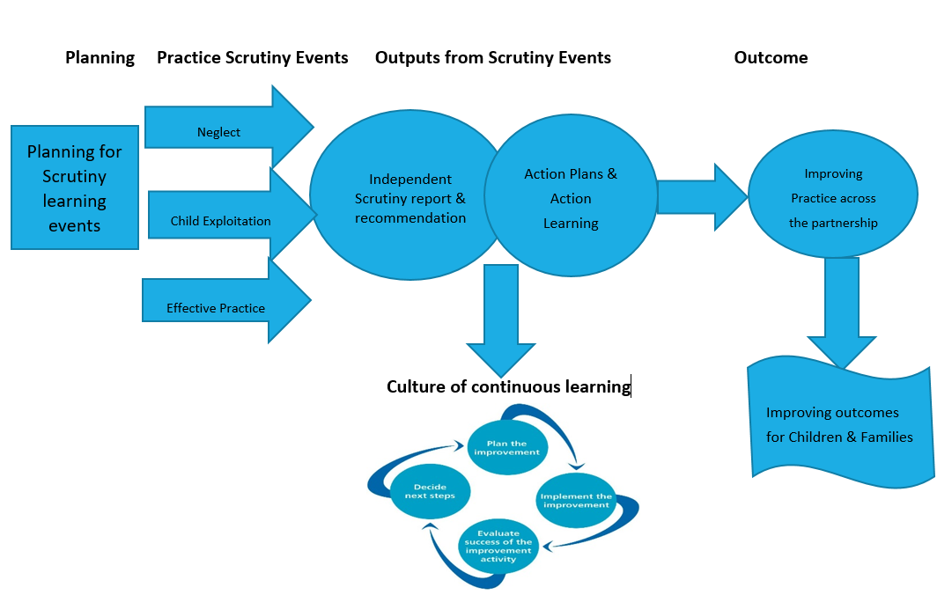

Governance and accountability
The partnership has delegated responsibility for the operational oversight and delivery of Quality Assurance to the Quality Assurance subgroup. This includes;
- Monitoring performance utilising a full range of Quality Assurance Processes
- Escalating areas of concern arising from Quality Assurance activities to the Steering Group
- Building a good understanding of how safe children are in West Sussex and where we need to improve
- Utilise the Performance Management Framework to identify trends and understand the context which may impact on performance
- Using local intelligence and national best practice to inform our approaches, strategies and plans to improve performance and outcomes for children and their families
- Providing evidence of the quality and impact of our work on the outcomes of children and their families in West Sussex which will feed into the scrutiny events
- Reflecting on practice; listening, learning and leading on improvements
- Testing the impact of improvement work on an ongoing basis
The relationship between the subgroups is important to highlight. The Case Review Subgroup is responsible for ensuring the recommendations from Serious Case Reviews, Child Safeguarding.
Practice Reviews and local learning reviews are completed. The Child Exploitation subgroup is responsible for quality assuring and driving the partnership approach to child exploitation.
The Learning and Development subgroup is responsible for ensuring that learning from Quality assurance and scrutiny is embedded in practice.
All the subgroups are accountable to the WSSCP Partnership through reporting directly to the Steering Group. The chairs will provide regular progress reporting to the WSSCP on the work of the group using the agreed impact template.
The responsibilities of individual agencies in relation to dissemination of learning, scrutiny and assurance activities is outlined in the purpose of the groups as laid in the WSSCP constitution and reinforced through the role descriptors for chairs and members of sub-groups and for members of the Partnership Board.

Conclusion
The partnership will adapt and review this framework annually, which includes independent scrutiny arrangements. This reinforces the ethos of continuous learning allowing the partnership to be forward thinking and outward looking while ensuring the approach to learning, scrutiny and quality assurance continues to be transparent and inclusive.

Acknowledgement: Thanks to the Bexley Safeguarding Children Partnership for sharing the learning from their scrutiny process and providing support and challenge for this framework.

Annex A – Approvals

Name | Title | Date of Approval
All Members | West Sussex Safeguarding Children Partnership Steering Group | June 2020

