Is this information kept by Children’s Social Care?  Yes - a record will be kept of the fact that your non-mobile child was referred and examined alongside the findings of that examination. You can request to see your records at any time by contacting Children’s Social Care on 01403 229900.  Our aim is to support you and keep you fully informed at all times of what is happening and why. Please feel free to ask questions at any time.  Further information is available from….  the West Sussex Health Visiting teams, including what they do, and their contact details is available by clicking on the link below:  West Sussex Health Visiting Teams  You should have been provided with contact details for your family’s Health Visitor, but general enquiries can be made using the phone number/email’s set out on the website link below  https://www.sussexcommunity.nhs.uk/services/servicedetails.htm?directoryID=22897  Children’s Social Care:  Tel. 01403 229900  NHS 111: Tel 111  West Sussex Safeguarding Children Partnership:  www.westsusssexscb.org.uk  Sussex procedures can be found online:  http://sussexchildprotection.procedures.org.uk |  | 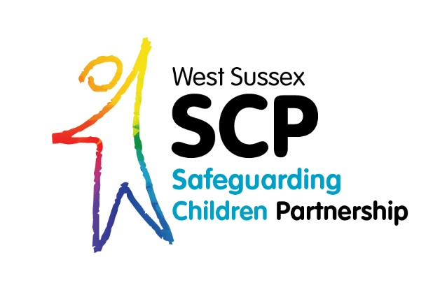  My Baby who is not yet rolling, crawling or walking has a bruise/unexplained skin mark, eye or oral injury. What happens  next?  The West Sussex  Bruise Guidance explained
Why is there concern that my child who is not yet rolling, crawling or walking may have a bruise/unexplained skin mark or injury to the eye/mouth.  Bruises/unexplained skin marks or eye/oral (mouth) injuries on a child who cannot crawl or walk are very unusual and research has shown that it can be a serious cause for concern.  What could be the reason for the bruise/unexplained skin mark or eye injury:  - It might not be a bruise/unexplained skin mark at all, it may be an unusual birthmark - not all birthmarks are present at birth but can appear days or weeks later.  - The bruise/unexplained skin mark or eye injury may be a sign of a medical condition such as a blood disorder which requires further medical investigation.  - The bruise/unexplained skin mark or eye injury can be a sign that your child has sustained an injury.  All staff in West Sussex follow the Bruising in Children who are Not Independently Mobile Guidance which specifies the actions they should take to protect children. |  | What is going to happen next?  - The professional who discussed your child’s bruise/unexplained mark or eye/oral injury with you has a duty to contact Children’s Social Care (CSC). A meeting will be held which includes children’s social care, the Police and a Paediatrician.  - You will be contacted and given an appointment, usually within 24hrs of the referral, for your child to be seen by a paediatrician (a doctor specialising in children). This may be at your local child development centre or hospital. This is done quickly because if any further treatment or investigations are required it is important this happens as soon as possible for your child.  - At the appointment the paediatrician will ask you about your child, examine your child fully and then decide if any further medical investigations are required. Any information you can give about your baby is extremely important in finding out the reason for your child’s bruise/unexplained skin mark or eye injury.  - The paediatrician will inform CSC of the outcome of your child’s examination. You will be told of any decisions taken and if there are any further actions required these will be discussed with you.

