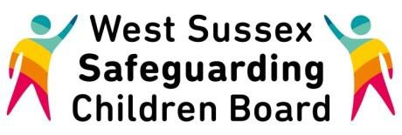

West Sussex Safeguarding Board Training Pathway

Explanatory Notes

The WSSCB, in line with the Children Act 2004, sets minimum standards for the provision of all Child Protection Training across the children’s workforce (this covers the statutory, voluntary and private sectors)

Statutory agencies have a responsibility, under Section 11 of the Children Act 2004, to ensure that all relevant staff and volunteers are trained to the required level, and to provide refresher and update training.

The WSSCB Training Pathway has been developed with the WSSCB Learning and Development Sub-Group in line with Working Together 2013. The Pathway aims assist you in identifying the appropriate level of child protection training for your role. Many WSSCB partner agencies have their own training pathways in relation to safeguarding. Training planning should be undertaken with reference to the individuals employing agency with the WSSCB Training Pathway viewed as the minimum standard.

Please find the WSSCB Training Pathway here. Where partner agencies have been developed in line with the Pathway, they can be found here. Should your agency wish to use the Pathway to
guide their own training planning, a blank copy can be found here.

Please note, any training undertaken via the WSSCB must only be done so with the agreement of your line manager. Please apply for WSSCB Training Course through the West Sussex Training Gateway.

