

**If you’re worried about something that’s happening to you or to a friend, there are a lot of people who can help you. It’s good to talk to people you trust about your worries, perhaps a teacher, a friend, your parents, or a family member. You may think that something happening to you or someone you know is not right. Abuse might not just be you, or someone you know, being physically or sexually hurt. It might also be you feeling frightened or worried about how someone is speaking to you or being scared of being shouted or sworn at or being frightened that you have seen someone else being hurt.**

**How To Get Help.**

**If you or a friend are in IMMEDIATE danger, you should treat this as an emergency and call 999 to speak to the Police.**

**You can contact ChildLine at www.childline.org.uk or by calling 0800 11 11**

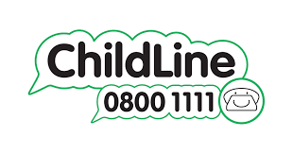

**If you have spoken to someone you trust or ChildLine and you are still concerned that you or a friend are being abused or neglected you can:**

**Contact the Integrated Front Door (IFD). The IFD is made up of different workers who can provide support and advice to help keep you safe. You can contact the IFD between 9am -5pm on 01403 229 900 or 0330 222 6664 between 5pm and 8am or email at** [**WSServices@westsussex.gov.uk**](mailto:WSServices@westsussex.gov.uk)