An Assessment Checklist
At each section consider whether there is anything that seems likely to have an impact on the child.
Physical care and wellbeing - is there any reason to be concerned about the child’s physical care and wellbeing in terms of?

A. Nutrition and Feeding
- Is the child regularly fed?
- Does the child eat enough food?
- Does the child eat appropriate food?
- Is the child patiently handled during feeding?
- Does the parent/carer seek help regarding nutrition/feeding problems?
- Is the child punished for not eating?
- Is the child encouraged to eat?
- Is the child encouraged to develop appropriate skills?
- Are there flexible routines?
- Is the parent/carer aware of the child being over or under weight?
- Is there evidence that the child is thriving?

B. Physical Warmth
- Is the child appropriately dressed for the weather?
- Is the bedroom appropriately heated?
- Is the house in general appropriately heated?

C. Physical Health (includes dental)
- Are physical health needs anticipated by parent?
- Do physical health needs get an appropriate and timely response from parents/carers?
- Is expert advice sought appropriately regarding non-emergencies?
- Is expert advice sought appropriately regarding emergencies?
- Is expert advice acted upon?
- Are any additional needs of the child understood and appropriately responded to?
- Does the parent/carer ignore or not recognise the need for diagnosis and/or treatment of physical health needs?
Does the parent/carer act in a way that increases the likelihood of poor outcomes for physical health?
- Is there appropriate and active management of any head lice?

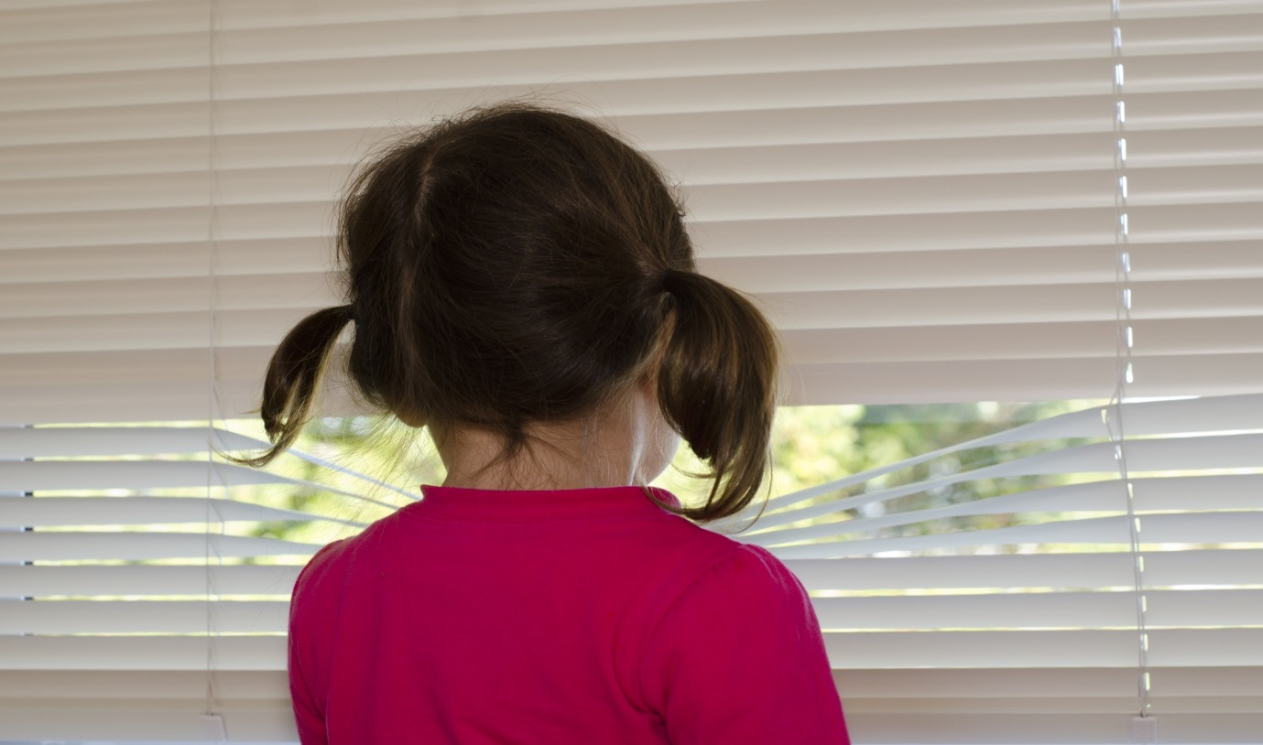

D. Mental and Emotional Health
- Does the parent/carer ignore or not recognise the need for diagnosis and/or treatment of mental and emotional health needs?
- Does the parent/carer refuse to allow or provide or facilitate diagnosis and/or treatment of mental and emotional health needs?
- Does the parent/carer act in a way that increases the likelihood of poor mental and emotional health? (This may include not taking known appropriate measures and/or not acting on advice in this respect).

E. Safety and Protection
- Is the child left alone inappropriately?
- Are all babysitters of an appropriate age and capability? And known to the child? And are adults or young people without obvious problems that may affect their ability to care for the child?
- Are there safe physical boundaries? For example, not allowed/able to wander from home; parents have clear ideas of limits of play areas
- Is there safety equipment, for example, stairgates and fireguards? Is the equipment in use?
- Can the windows and doors be opened by a child if unsafe for them to do so?
- Are dangerous household substances (e.g. bleach and cleaners) kept safely?
- Are dangerous personal items (e.g. medication, needles and drugs) kept safely?
- Is dangerous household equipment (e.g. knives, lighters, electrical appliances) accessible to children?
- Is there effective supervision in potentially dangerous situations in and outside of the home?
- Is the child expected/allowed to do inappropriate dangerous tasks, e.g. cooking, lighting fires, supervising very young siblings etc.?
- Is there a history of fire setting, in or outside of the home, by any member of the family?
- Is the area immediately around the home safe? E.g. are there accessible dangerous objects, balconies, stairwells etc.?

F. Cleanliness
- Is general hygiene in the home reasonable?
- Is animal mess cleaned up promptly? Or is it left within reach of the child?
- Is old food cleared away?
- Is rubbish disposed of safely?
- Does the child have clean clothing available?
- Does the child smell? If they do, are they teased/rejected by peers?
- Is there bedding available? If so, is it clean and dry?
- Is food stored hygienically?
- Is the toilet cleaned on a regular basis?
- Are there facilities for washing and bathing? Are they used regularly?
- Does the house have an unclean smell?

G. Possessions and Personal Space
- Does the child have his/her own clothing?
- Does the child play with age appropriate toys?
- Does the child have toys of his/her own?
- Does the child have personal space (e.g. bedroom), including personal privacy?
- Does the child have appropriate personal possessions?

H. Animals and Pets
- Are the pets appropriately cared for?
- Are the needs of the pet(s) prioritised over those of the child?
- Are pets safe in terms of harm to the child?
- Do the parents/carers ensure the child learns to behave appropriately with pets, and take appropriate responsibility for them (if age appropriate)?
- Is a significant proportion of family income being spent on the pets(s)? To the detriment of the child?
- Is access to, or ill-treatment of a pet, being
used to control or punish the child?
Are animals harmed by any member of or visitors to the household?

I. Visitors to the Household
- Is the child’s home often frequented by ‘visitors’, i.e. adults or young people who have no significant relationship with them?
- Is the child left in the care of ‘visitors’?
- Does the presence of ‘visitors’ disrupt the child’s normal routines or result in inappropriate routines?
- Do the needs of the ‘visitors’ take priority over those of the child?
- Do ‘visitors’ stay overnight?
- Are ‘visitors’ genuinely friends of a parent, or are they exploiting or abusing a parent?

J. Parent/carer’s Emotional Involvement with the Child
- Is the child comforted when distressed?
- Does the parent expect comfort from the child when the parent is distressed?
- Is the child denigrated?
- Is the child praised/rewarded for achievements?
- Does the parent/carer emphasise or punish failure?
- Does the parent/carer have limited physical and emotional contact with the child?
- Is affection shown and expressed?
- Do the parents/carers have a negative attitude towards the child?
- Do the parents lack emotional maturity?
- Is there a sense of belonging and security in the family? i.e. a sense of the parents/carers commitment to the child and to protect the child?
- Is the child free to express themselves?

K. Routines
- Are routines regarding meals, bedtimes, access to television, school attendance, homework, age appropriate?
- Are routines consistent and consistently applied?

L. Controls
- Is the child locked or shut in rooms or a cupboard etc.?
- Is the child subject to punishment or sanctions that cause damage or pain?
- Is the parent able to instigate/ maintain appropriate controls and/or maintain structure/ routines and/or ensure safety and protection?

M. Parent’s/Carer’s Expectations of the Child
- Are the parent’s/carer’s expectations age appropriate?
- Are the parent’s/carer’s expectations of ability appropriate?
- Is there awareness of the child’s needs?
- Is there awareness of the child’s developmental progress?
- Are the parent’s/carer’s expectations realistic?
- Are the parent’s/carer’s expectations consistent?
- Is the child expected or allowed to act as a carer for the parent/carer or sibling?

N. Domestic Violence and Abuse
• Does the child experience domestic violence and abuse as a part of family life? (‘Experience’ means being aware of, not just being actually involved in it or seeing it)

O. Parent’s/Carer’s Behaviour
- Is the parent/carer able to instigate and maintain basic routines?
- Is the parent’s/carer’s behaviour chaotic and/ or unpredictable and/or inconsistent?
- Does the parent/carer allow multiple carers? Do they have a relationship with the child?
- Does the parent/carer allow age/gender appropriate carers?
- Does the parent/carer leave the child unattended?
- Does the parent/carer provide reactive rather than proactive care?
- Does the parent/carer treat animals better than the child?
- Does the parent/carer acquire possessions for themselves, but markedly less so for child?
Does the parent/carer provide better living conditions for themselves than for the child? (For example, bedrooms).
- Does the parent/carer help the child to know right from wrong?
- Does the parent/carer involve the child in criminal/drug related/anti-social behaviour?
- Does the parent/carer attempt to address child’s inappropriate behaviour? For example, committing offences, causing damage, being abusive and/or threatening, not attending school and so on.
- Does the parent/carer allow, encourage, or fail to prevent bullying by siblings?

P. Leisure Activity
- Does the child have access to age inappropriate video, DVD, computer games etc.?
- Does the child have access to adult pornography?
- Does the child have uncontrolled access to the internet?
- Does the child have unrestricted access to late-night television?
- Is the child supervised by a responsible person during potentially dangerous leisure activities?
- Is the child allowed to take part in age inappropriate activities?

Q. Self-Harming
- Self-harming may include using drugs or alcohol or deliberate exposure to danger.
- Does the child experience self-harming, or threats of self-harming by a parent/carer or sibling as part of family life?
- Is the child self-harming, or threatening self harm?

R. Educational Needs
- Does the parent/carer ensure the child receives an appropriate education?
- Does the parent/carer allow and/or recognise the need for treatment and/or services regarding serious educational problems or needs?
- Is the parent/carer involved in the child’s education? (E.g. assisting with homework, ensuring child has equipment, engaging with teachers as appropriate, and so on)
- Is the child unable to access the curriculum or fully benefit from the educational experience? (E.g. because of their or others behaviour in class, relationships with peers and/or adults in school, ability to concentrate and/or learn, punctuality and/or attendance, social skills and/or acceptability and so on).

S. Parents/Carers Attitudes to Professionals
- Are parents/carers likely to refuse (actually or effectively) to be involved with professionals?
- Is there any history of disguised or noncompliance?
- Do parents/carers accept that professional involvement is appropriate?
- Do parents/carers accept that professional involvement is necessary?

T. History and Context
- Is there a history or context of current concerns in terms of?
- Abuse or neglect?
- Mental ill health?
- Learning disability?
- Drug or alcohol misuse?
- Poverty or financial problems?
- Homelessness?
- Frequent changes of home and/or school?
- Child going missing, with or without parents/ carers?
- Addictive behaviour by parents/carers?

U. The Child
- Is the child seen as being ‘difficult’? (Crying, refusing to engage with parents or in play and so on)
- Is the child ‘passive’? (i.e. vacant facial expression, failing to respond to adults, reluctant to play)
- Is the child able to enjoy social intercourse, take turns, and respond to adult interest and so on?
- Does the child have a secure attachment to parent/carer?
- Does the child have strong feelings of self-worth and self-confidence?
If there are concerns regarding the child’s behaviour, demeanour, development and/or emotional well-being, consider the following in more detail. These checklists are intended for use by professionals who are involved in identifying possible issues for a child and parents/carers. An ‘expert’ opinion - for example from a psychiatrist - is not necessarily required in this context, but may be if issues appear to warrant exploration in more detail

